UNITED STATES
SECURITIES AND EXCHANGE COMMISSION
Washington, D.C. 20549
_____________________________
SCHEDULE 14A
PROXY STATEMENT PURSUANT TO SECTION 14(a) OF THE
SECURITIES EXCHANGE ACT OF 1934
_____________________________
Filed by the Registrant x
Filed by a Party other than the Registrant o
Check the appropriate box:
o Preliminary Proxy Statement
o Confidential, for Use of the Commission Only (as permitted by Rule 14a-6(e)(2))
o Definitive Proxy Statement
x Definitive Additional Materials
o Soliciting Material Pursuant to §240.14a-11(c) or §240.14a-2
Seer, Inc.
(Name of Registrant as Specified In Its Charter)
Payment of Filing Fee (Check the appropriate box):
x | No fee required
o | Fee paid previously with preliminary materials
o | Fee computed on table in exhibit required by Item 25(b) per Exchange Act Rules 14a-6(i)(1) and 0-11

May 28, 2025

Your Vote Counts! SEER, INC. 2024 Annual Meeting Vote by June 11, 2024 11:59 PM ET SEER, INC. 3800 BRIDGE PARKWAY, SUITE 102 REDWOOD CITY, CALIFORNIA 94065 V35568-P07175 You invested in SEER, INC. and it’s time to vote! You have the right to vote on proposals being presented at the Annual Meeting. This is an important notice regarding the availability of proxy material for the stockholder meeting to be held on June 12, 2024. Get informed before you vote View the Notice & Proxy Statement and Form 10-K online OR you can receive a free paper or email copy of the material(s) by requesting prior to May 29, 2024. If you would like to request a copy of the material(s) for this and/or future stockholder meetings, you may (1) visit www.ProxyVote.com, (2) call 1-800-579-1639 or (3) send an email to sendmaterial@proxyvote.com. If sending an email, please include your control number (indicated below) in the subject line. Unless requested, you will not otherwise receive a paper or email copy. For complete information and to vote, visit www.ProxyVote.com Control # Smartphone users Point your camera here and vote without entering a control number Vote Virtually at the Meeting* June 12, 2024 1:00 PM PDT Virtually at: www.virtualshareholdermeeting.com/SEER2024 *Please check the meeting materials for any special requirements for meeting attendance.
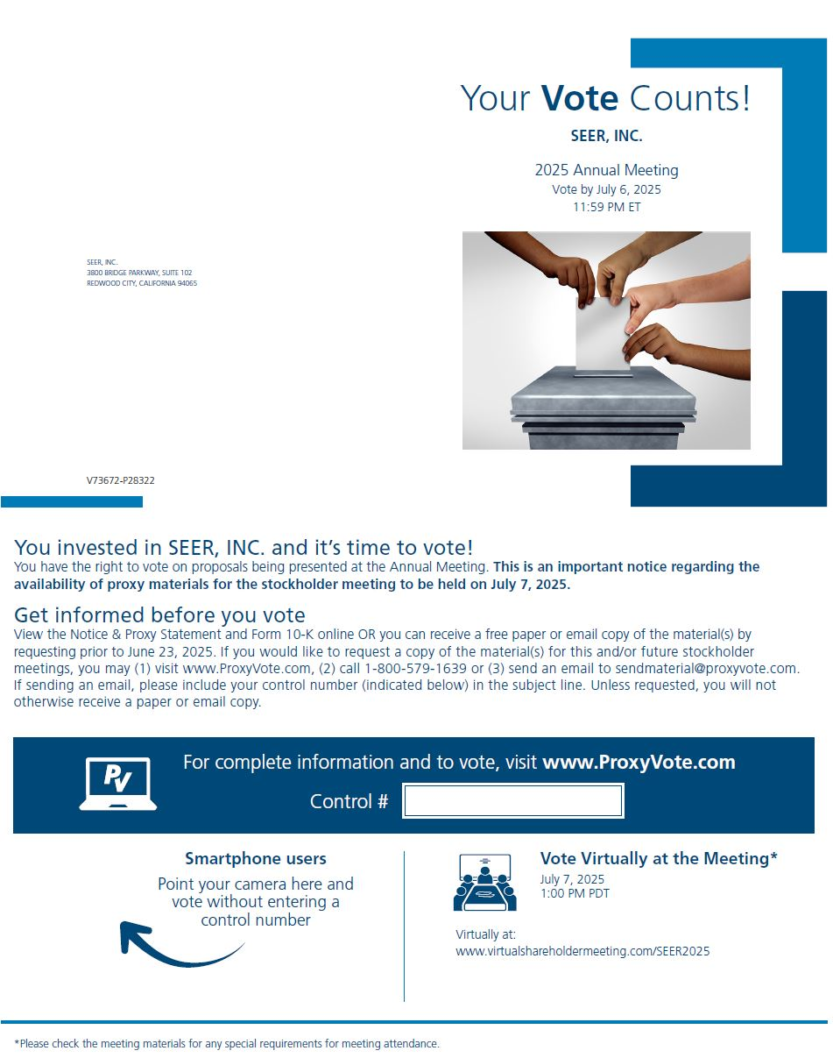

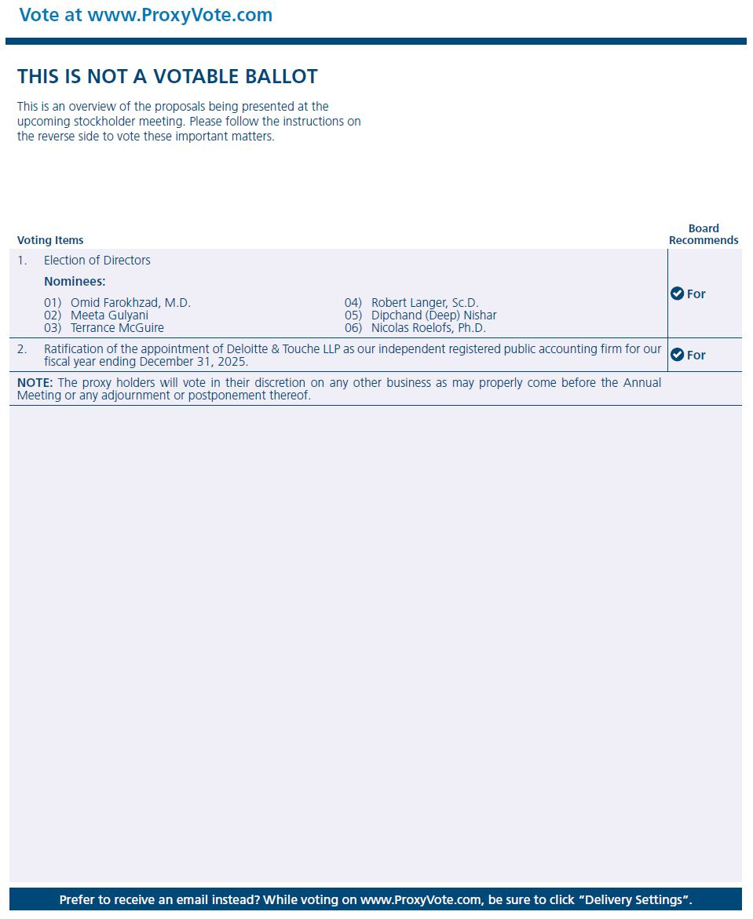
Ratification of the appointment of Deloitte & Touche LLP as our independent registered public accounting firm for our fiscal year ending December 31, 2024. NOTE: The proxy holders will vote in their discretion on any other business as may properly come before the Annual Meeting or any adjournment or postponement thereof. For For Prefer to receive an email instead? While voting on www.ProxyVote.com, be sure to click “Delivery Settings”. V35569-P0717

