UNITED STATES
SECURITIES AND EXCHANGE COMMISSION
Washington, D.C. 20549

SCHEDULE 14A
Proxy Statement Pursuant to Section 14(a) of the
Securities Exchange Act of 1934

Filed by the Registrant ☒
Filed by a Party other than the Registrant ☐
Check the appropriate box:

☐ | Preliminary Proxy Statement

☐ | Confidential, for Use of the Commission Only (as permitted by Rule 14a-6(e)(2))

☐ | Definitive Proxy Statement

☒ | Definitive Additional Materials

☐ | Soliciting Material Pursuant to §240.14a-12
Seer, Inc.
(Name of Registrant as Specified In Its Charter)
(Name of Person(s) Filing Proxy Statement, if other than the Registrant)
Payment of the Filing Fee (Check the appropriate box):

☒ | No fee required.

☐ | Fee paid previously with preliminary materials.

☐ | Fee computed on table in exhibit required by Item 25(b) per Exchange Act Rules 14a-6(i)(1) and 0-11

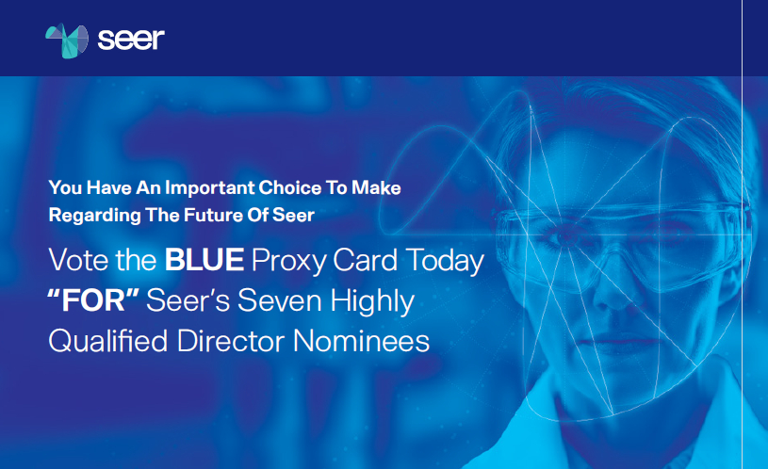
Dear Fellow Seer Stockholder,
At our upcoming Annual Meeting of Stockholders on July 28, 2026, your vote is critical to the continued success of Seer.
Seer has a purpose-built Board of Directors with the expertise needed to guide a category-creating life sciences tools company. This Board is committed to overseeing our strategy to pioneer the nascent space of proteomics using the Board’s decades of industry knowledge and insight.
At the Annual Meeting, Bradley Radoff and Michael Torok are attempting to replace three of your Board’s sitting directors — Seer’s Co-Founder, CEO and Chair Omid Farokhzad, M.D., Terrance McGuire and Dipchand (Deep) Nishar — with candidates who bring no proteomics experience, no life sciences tools experience and no platform operating experience. Radoff and Torok have offered no plan to build Seer. Their only desire is to strip Seer of its cash. Additionally, their nominees raise serious concerns regarding independence and their ability to act in the best interests of all stockholders.

The Three Directors that Radoff and Torok Are Trying to Remove Are Critical to Seer’s Future

 |  | OMID FAROKHZAD, M.D  Co-Founder, CEO and Chair;  Director since 2017 |  |  |  | Scientific architect of the Proteograph® Product Suite
 |  |  |  |  |  | Founder of multiple life sciences platform companies
 |  |  |  |  |  | Author of 200+ scientific papers and inventor on 250+ patents
 |  |  |  |  |  | Seer’s largest long-term stockholder, together with family entities
 |  | TERRANCE MCGUIRE  Founding Partner of Polaris  Partners; Director since 2017 |  |  |  | Decades of healthcare investing and company-building experience
 |  |  |  |  |  | Proven capital allocation and governance judgment
 |  |  |  |  |  | Investor in Seer at inception and again at Seer’s IPO
 |  |  |  |  |  | One of Seer’s longest-term stockholders
 |  | DIPCHAND (DEEP) NISHAR  Technology and Growth  Leader; Director since 2021 |  |  |  | Former Senior Managing Partner at SoftBank Vision Fund
 |  |  |  |  |  | Former Managing Director at General Catalyst
 |  |  |  |  |  | Former senior executive at LinkedIn and Google
 |  |  |  |  |  | Deep capital markets, growth investing and corporate strategy expertise



Seer’s Nominees Have the Right Experience, Radoff and Torok’s Nominees Do Not

Critical Experience Needed at Seer |  |  |  | Seer’s  Director Nominees |  | Radoff and  Torok’s Nominees
 |  | Proteomics or adjacent scientific platform expertise
 |  | Life sciences tools operating experience
 |  | Experience scaling innovative technology platforms
 |  | Public company governance experience relevant to Seer
 |  | Capital allocation discipline
 |  | Long-term alignment with Seer stockholders
 |  | Direct role in building Seer’s strategy
The Board thoughtfully evaluated the three director candidates identified by Radoff and Torok and unanimously determined that they lack the relevant skillsets, experience and independence required to oversee a complex proteomics company at a critical stage of its evolution in a nascent market. The Board also offered, in good faith, to interview these candidates. Radoff and Torok declined to make them available for customary interviews. Radoff and Torok’s actions demonstrate an unwillingness to work constructively with the Board, and we believe that their nominees would diminish the overall quality of our purpose-built Board.
The issue is not whether Radoff and Torok’s nominees have experience in other fields. The issue is whether they have the right experience for Seer. They do not.
Radoff and Torok are not merely proposing alternative directors. They are trying to install nominees who, in our view, appear selected to advance their short-term agenda.

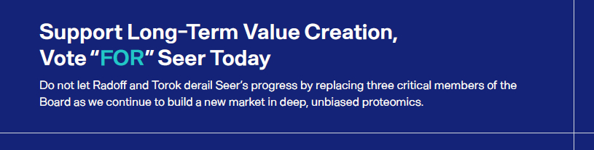

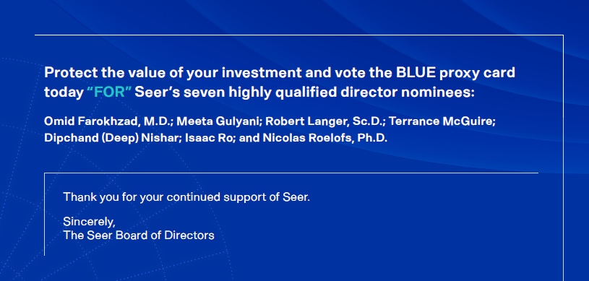

If you have any questions or
require any assistance with
voting your shares, please call: |  | Stockholders may call toll free: (877) 456-3524

Forward-Looking Statements
This communication contains “forward-looking statements” within the meaning of the Private Securities Litigation Reform Act of 1995, as amended. Such forward-looking statements are based on Seer’s beliefs and assumptions and on information currently available to it on the date of this press release. Forward-looking statements may involve known and unknown risks, uncertainties, and other factors that may cause Seer’s actual results, performance, or achievements to be materially different from those expressed or implied by the forward-looking statements. These statements include but are not limited to statements regarding Seer’s plans, strategies, expectations, strategic opportunities, business objectives, research and development initiatives, and prospects. These and other risks are described more fully in Seer’s filings with the Securities and Exchange Commission and other documents that Seer subsequently files with the Securities and Exchange Commission from time to time. Except to the extent required by law, Seer undertakes no obligation to update such statements to reflect events that occur or circumstances that exist after the date on which they were made.



