UNITED STATES
SECURITIES AND EXCHANGE COMMISSION
Washington, D.C. 20549

SCHEDULE 14A
Proxy Statement Pursuant to Section 14(a) of the
Securities Exchange Act of 1934

Filed by the Registrant ☒
Filed by a Party other than the Registrant ☐
Check the appropriate box:

☐ | Preliminary Proxy Statement

☐ | Confidential, for Use of the Commission Only (as permitted by Rule 14a-6(e)(2))

☐ | Definitive Proxy Statement

☒ | Definitive Additional Materials

☐ | Soliciting Material Pursuant to §240.14a-12
Seer, Inc.
(Name of Registrant as Specified In Its Charter)
(Name of Person(s) Filing Proxy Statement, if other than the Registrant)
Payment of the Filing Fee (Check the appropriate box):

☒ | No fee required.

☐ | Fee paid previously with preliminary materials.

☐ | Fee computed on table in exhibit required by Item 25(b) per Exchange Act Rules 14a-6(i)(1) and 0-11

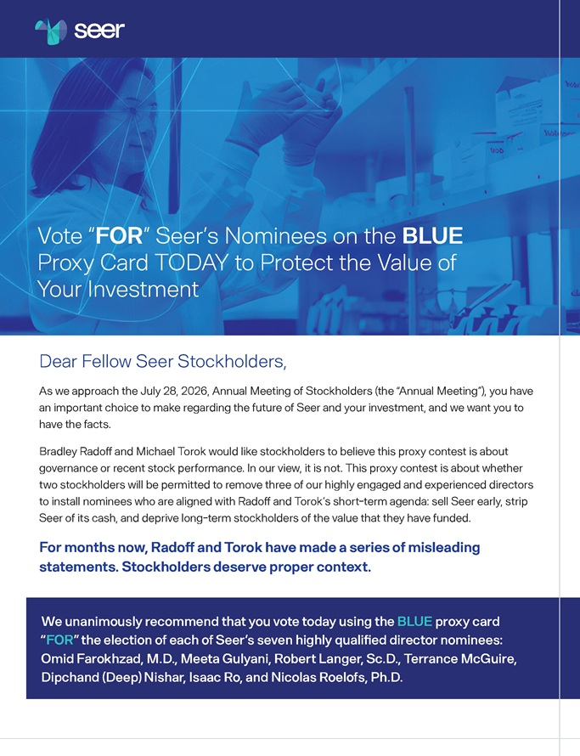
Vote “FOR” Seer’s Nominees on the BLUE Proxy Card TODAY to Protect the Value of Your Investment Vote “FOR” Seer’s Nominees on the BLUE Proxy Card TODAY to Protect the Value of Your Investment Dear Fellow Seer Stockholders, As we approach the July 28, 2026, Annual Meeting of Stockholders (the “Annual Meeting”), you have an important choice to make regarding the future of Seer and your investment, and we want you to have the facts. Bradley Radoff and Michael Torok would like stockholders to believe this proxy contest is about governance or recent stock performance. In our view, it is not. This proxy contest is about whether two stockholders will be permitted to remove three of our highly engaged and experienced directors to install nominees who are aligned with Radoff and Torok’s short-term agenda: sell Seer early, strip Seer of its cash, and deprive long-term stockholders of the value that they have funded. For months now, Radoff and Torok have made a series of misleading statements. Stockholders deserve proper context. We unanimously recommend that you vote today using the BLUE proxy card “FOR” the election of each of Seer’s seven highly qualified director nominees: Omid Farokhzad, M.D., Meeta Gulyani, Robert Langer, Sc.D., Terrance McGuire, Dipchand (Deep) Nishar, Isaac Ro, and Nicolas Roelofs, Ph.D.

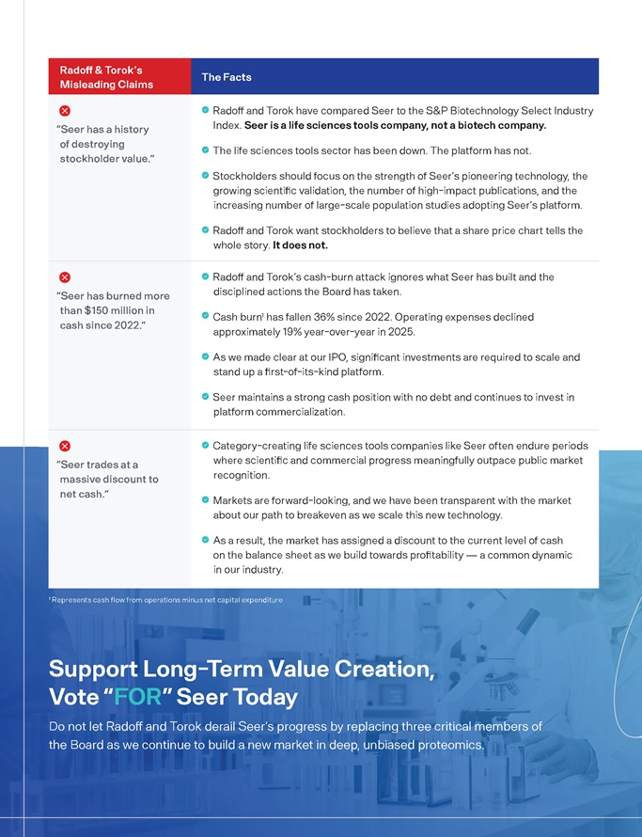
Radoff & Torok’s Misleading Claims The Facts “Seer has a history of destroying stockholder value.” Radoff and Torok have compared Seer to the S&P Biotechnology Select Industry Index. Seer is a life sciences tools company, not a biotech company. The life sciences tools sector has been down. The platform has not. Stockholders should focus on the strength of Seer’s pioneering technology, the growing scientific validation, the number of high-impact publications, and the increasing number of large-scale population studies adopting Seer’s platform. Radoff and Torok want stockholders to believe that a share price chart tells the whole story. It does not. “Seer has burned more than $150 million in cash since 2022.” Radoff and Torok’s cash-burn attack ignores what Seer has built and the disciplined actions the Board has taken. Cash burn1 has fallen 36% since 2022. Operating expenses declined approximately 19% year-over-year in 2025. As we made clear at our IPO, significant investments are required to scale and stand up a first-of-its-kind platform. Seer maintains a strong cash position with no debt and continues to invest in platform commercialization. “Seer trades at a massive discount to net cash.” Category-creating life sciences tools companies like Seer often endure periods where scientific and commercial progress meaningfully outpace public market recognition. Markets are forward-looking, and we have been transparent with the market about our path to breakeven as we scale this new technology. As a result, the market has assigned a discount to the current level of cash on the balance sheet as we build towards profitability — a common dynamic in our industry. 1 Represents cash flow from operations minus net capital expenditure Support Long-Term Value Creation, Vote “FOR” Seer Today Do not let Radoff and Torok derail Seer’s progress by replacing three critical members of the Board as we continue to build a new market in deep, unbiased proteomics.

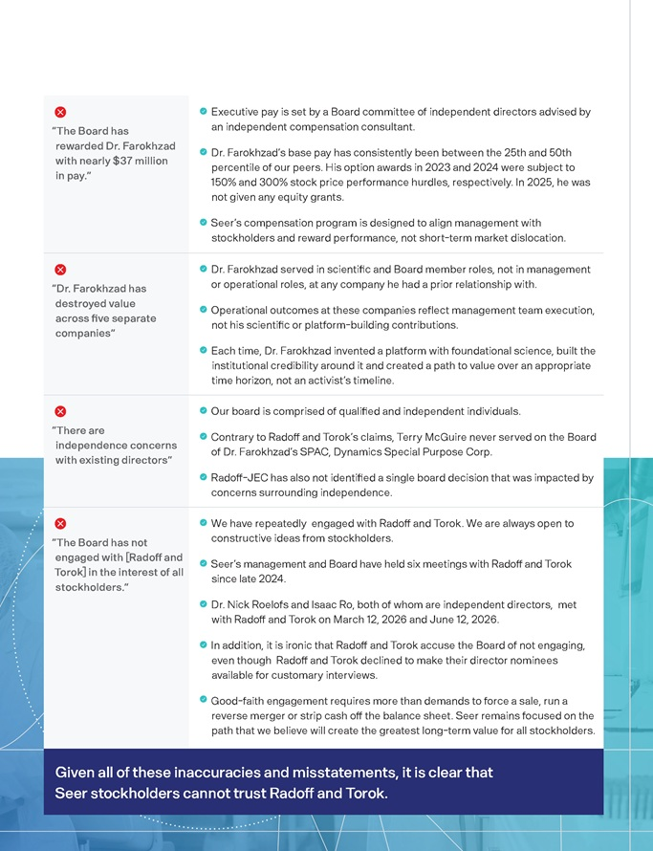
“The Board has rewarded Dr. Farokhzad with nearly $37 million in pay.” Executive pay is set by a Board committee of independent directors advised by an independent compensation consultant. Dr. Farokhzad’s base pay has consistently been between the 25th and 50th percentile of our peers. His option awards in 2023 and 2024 were subject to 150% and 300% stock price performance hurdles, respectively. In 2025, he was not given any equity grants. Seer’s compensation program is designed to align management with stockholders and reward performance, not short-term market dislocation. “Dr. Farokhzad has destroyed value across five separate companies” Dr. Farokhzad served in scientific and Board member roles, not in management or operational roles, at any company he had a prior relationship with. Operational outcomes at these companies reflect management team execution, not his scientific or platform-building contributions. Each time, Dr. Farokhzad invented a platform with foundational science, built the institutional credibility around it and created a path to value over an appropriate time horizon, not an activist’s timeline. “There are independence concerns with existing directors” Our board is comprised of qualified and independent individuals. Contrary to Radoff and Torok’s claims, Terry McGuire never served on the Board of Dr. Farokhzad’s SPAC, Dynamics Special Purpose Corp. Radoff-JEC has also not identified a single board decision that was impacted by concerns surrounding independence. “The Board has not engaged with [Radoff and Torok] in the interest of all stockholders.” We have repeatedly engaged with Radoff and Torok. We are always open to constructive ideas from stockholders. Seer’s management and Board have held six meetings with Radoff and Torok since late 2024. Dr. Nick Roelofs and Isaac Ro, both of whom are independent directors, met with Radoff and Torok on March 12, 2026 and June 12, 2026. In addition, it is ironic that Radoff and Torok accuse the Board of not engaging, even though Radoff and Torok declined to make their director nominees available for customary interviews. Good-faith engagement requires more than demands to force a sale, run a reverse merger or strip cash off the balance sheet. Seer remains focused on the path that we believe will create the greatest long-term value for all stockholders. Given all of these inaccuracies and misstatements, it is clear that Seer stockholders cannot trust Radoff and Torok.

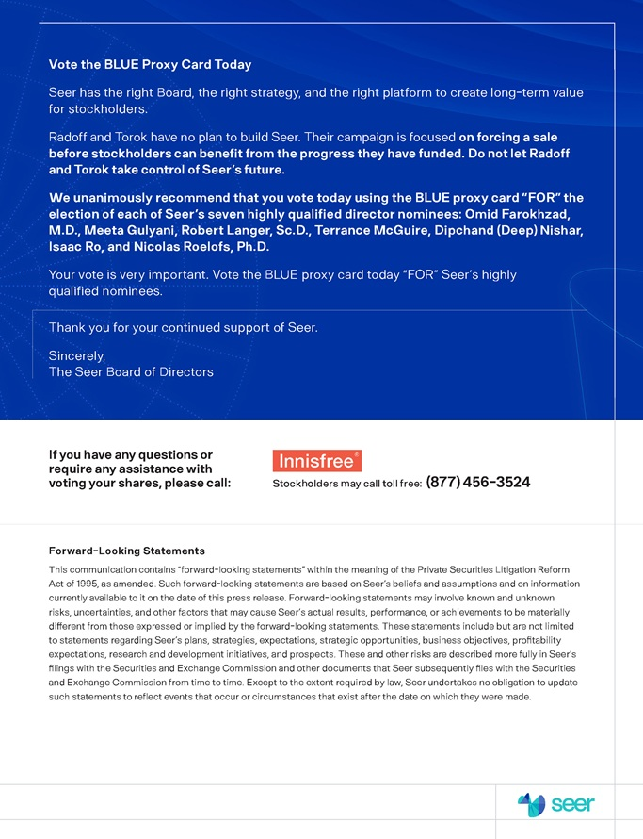
Vote the BLUE Proxy Card Today Seer has the right Board, the right strategy, and the right platform to create long-term value for stockholders. Radoff and Torok have no plan to build Seer. Their campaign is focused on forcing a sale before stockholders can benefit from the progress they have funded. Do not let Radoff and Torok take control of Seer’s future. We unanimously recommend that you vote today using the BLUE proxy card “FOR” the election of each of Seer’s seven highly qualified director nominees: Omid Farokhzad, M.D., Meeta Gulyani, Robert Langer, Sc.D., Terrance McGuire, Dipchand (Deep) Nishar, Isaac Ro, and Nicolas Roelofs, Ph.D. Your vote is very important. Vote the BLUE proxy card today “FOR” Seer’s highly qualified nominees. Thank you for your continued support of Seer. Sincerely, The Seer Board of Directors If you have any questions or require any assistance with voting your shares, please call: Stockholders may call toll free: (877) 456-3524 Forward-Looking Statements This communication contains “forward-looking statements” within the meaning of the Private Securities Litigation Reform Act of 1995, as amended. Such forward-looking statements are based on Seer’s beliefs and assumptions and on information currently available to it on the date of this press release. Forward-looking statements may involve known and unknown risks, uncertainties, and other factors that may cause Seer’s actual results, performance, or achievements to be materially different from those expressed or implied by the forward-looking statements. These statements include but are not limited to statements regarding Seer’s plans, strategies, expectations, strategic opportunities, business objectives, profitability expectations, research and development initiatives, and prospects. These and other risks are described more fully in Seer’s filings with the Securities and Exchange Commission and other documents that Seer subsequently files with the Securities and Exchange Commission from time to time. Except to the extent required by law, Seer undertakes no obligation to update such statements to reflect events that occur or circumstances that exist after the date on which they were made.

