UNITED STATES
SECURITIES AND EXCHANGE COMMISSION
Washington, D.C. 20549

SCHEDULE 14A
Proxy Statement Pursuant to Section 14(a) of the
Securities Exchange Act of 1934

Filed by the Registrant ☒
Filed by a Party other than the Registrant ☐
Check the appropriate box:

☐ | Preliminary Proxy Statement

☐ | Confidential, for Use of the Commission Only (as permitted by Rule 14a-6(e)(2))

☐ | Definitive Proxy Statement

☒ | Definitive Additional Materials

☐ | Soliciting Material Pursuant to §240.14a-12
Seer, Inc.
(Name of Registrant as Specified In Its Charter)
(Name of Person(s) Filing Proxy Statement, if other than the Registrant)
Payment of the Filing Fee (Check the appropriate box):

☒ | No fee required.

☐ | Fee paid previously with preliminary materials.

☐ | Fee computed on table in exhibit required by Item 25(b) per Exchange Act Rules 14a-6(i)(1) and 0-11

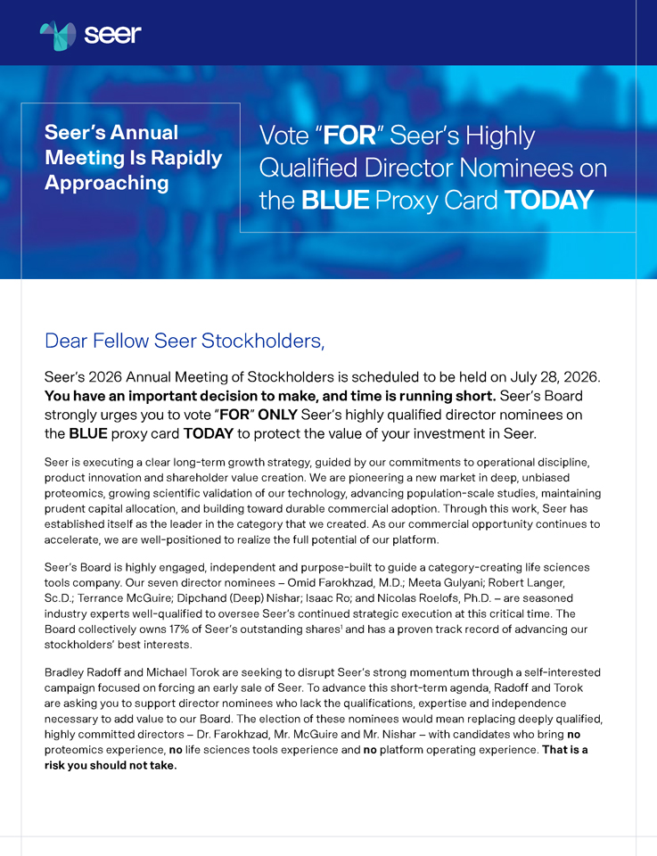
Seer’s Annual Meeting Is Rapidly Approaching Vote “FOR” Seer’s Highly Qualified Director Nominees on the BLUE Proxy Card TODAY Dear Fellow Seer Stockholders, Seer’s 2026 Annual Meeting of Stockholders is scheduled to be held on July 28, 2026. You have an important decision to make, and time is running short. Seer’s Board strongly urges you to vote “FOR” ONLY Seer’s highly qualified director nominees on the BLUE proxy card TODAY to protect the value of your investment in Seer. Seer is executing a clear long-term growth strategy, guided by our commitments to operational discipline, product innovation and shareholder value creation. We are pioneering a new market in deep, unbiased proteomics, growing scientific validation of our technology, advancing population-scale studies, maintaining prudent capital allocation, and building toward durable commercial adoption. Through this work, Seer has established itself as the leader in the category that we created. As our commercial opportunity continues to accelerate, we are well-positioned to realize the full potential of our platform. Seer’s Board is highly engaged, independent and purpose-built to guide a category-creating life sciences tools company. Our seven director nominees – Omid Farokhzad, M.D.; Meeta Gulyani; Robert Langer, Sc.D.; Terrance McGuire; Dipchand (Deep) Nishar; Isaac Ro; and Nicolas Roelofs, Ph.D. – are seasoned industry experts well-qualified to oversee Seer’s continued strategic execution at this critical time. The Board collectively owns 17% of Seer’s outstanding shares1 and has a proven track record of advancing our stockholders’ best interests. Bradley Radoff and Michael Torok are seeking to disrupt Seer’s strong momentum through a self-interested campaign focused on forcing an early sale of Seer. To advance this short-term agenda, Radoff and Torok are asking you to support director nominees who lack the qualifications, expertise and independence necessary to add value to our Board. The election of these nominees would mean replacing deeply qualified, highly committed directors – Dr. Farokhzad, Mr. McGuire and Mr. Nishar – with candidates who bring no proteomics experience, no life sciences tools experience and no platform operating experience. That is a risk you should not take.

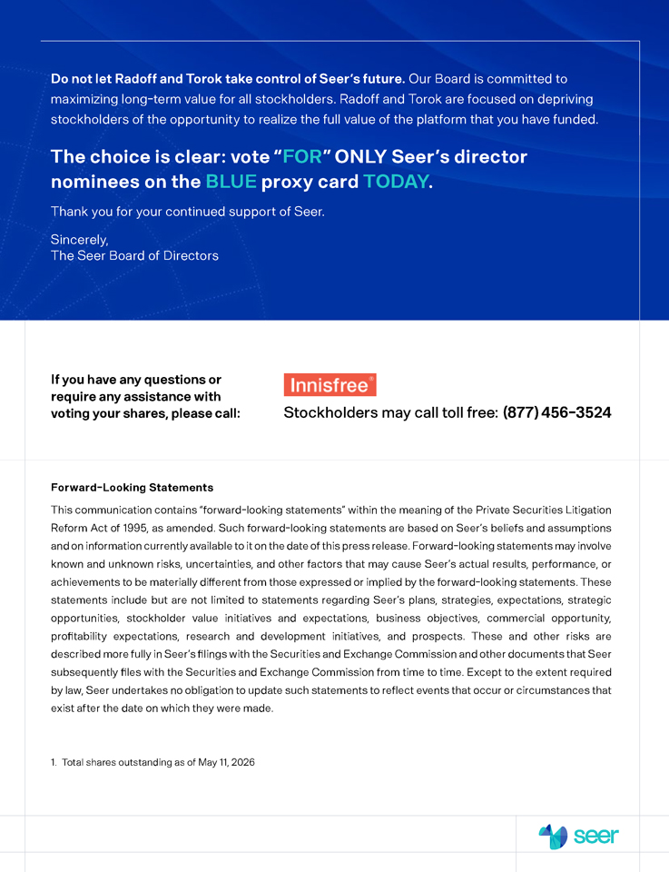
Do not let Radoff and Torok take control of Seer’s future. Our Board is committed to maximizing long-term value for all stockholders. Radoff and Torok are focused on depriving stockholders of the opportunity to realize the full value of the platform that you have funded. The choice is clear: vote “FOR” ONLY Seer’s director nominees on the BLUE proxy card TODAY. Thank you for your continued support of Seer. Sincerely, The Seer Board of Directors If you have any questions or require any assistance with voting your shares, please call: Stockholders may call toll free: (877) 456-3524 Forward-Looking Statements This communication contains “forward-looking statements” within the meaning of the Private Securities Litigation Reform Act of 1995, as amended. Such forward-looking statements are based on Seer’s beliefs and assumptions and on information currently available to it on the date of this press release. Forward-looking statements may involve known and unknown risks, uncertainties, and other factors that may cause Seer’s actual results, performance, or achievements to be materially different from those expressed or implied by the forward-looking statements. These statements include but are not limited to statements regarding Seer’s plans, strategies, expectations, strategic opportunities, stockholder value initiatives and expectations, business objectives, commercial opportunity, profitability expectations, research and development initiatives, and prospects. These and other risks are described more fully in Seer’s filings with the Securities and Exchange Commission and other documents that Seer subsequently files with the Securities and Exchange Commission from time to time. Except to the extent required by law, Seer undertakes no obligation to update such statements to reflect events that occur or circumstances that exist after the date on which they were made. 1. Total shares outstanding as of May 11, 2026

