UNITED STATES
SECURITIES AND EXCHANGE COMMISSION
Washington, D.C. 20549

SCHEDULE 14A
Proxy Statement Pursuant to Section 14(a) of the
Securities Exchange Act of 1934

Filed by the Registrant ☒
Filed by a Party other than the Registrant ☐
Check the appropriate box:

☐ | Preliminary Proxy Statement

☐ | Confidential, for Use of the Commission Only (as permitted by Rule 14a-6(e)(2))

☐ | Definitive Proxy Statement

☒ | Definitive Additional Materials

☐ | Soliciting Material Pursuant to §240.14a-12
Seer, Inc.
(Name of Registrant as Specified In Its Charter)
(Name of Person(s) Filing Proxy Statement, if other than the Registrant)
Payment of the Filing Fee (Check the appropriate box):

☒ | No fee required.

☐ | Fee paid previously with preliminary materials.

☐ | Fee computed on table in exhibit required by Item 25(b) per Exchange Act Rules 14a-6(i)(1) and 0-11

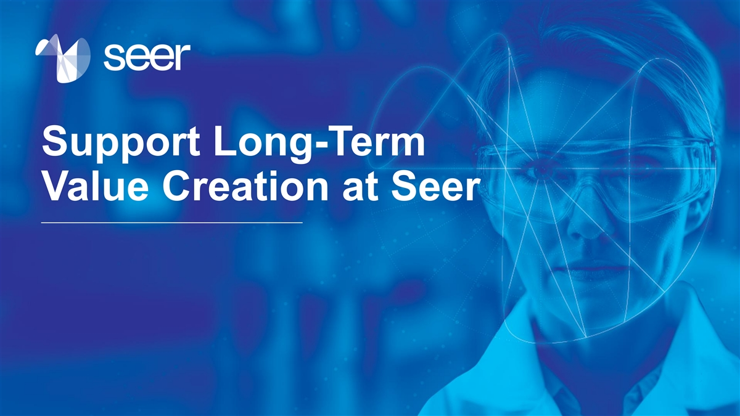
Support Long-Term Value Creation at Seer

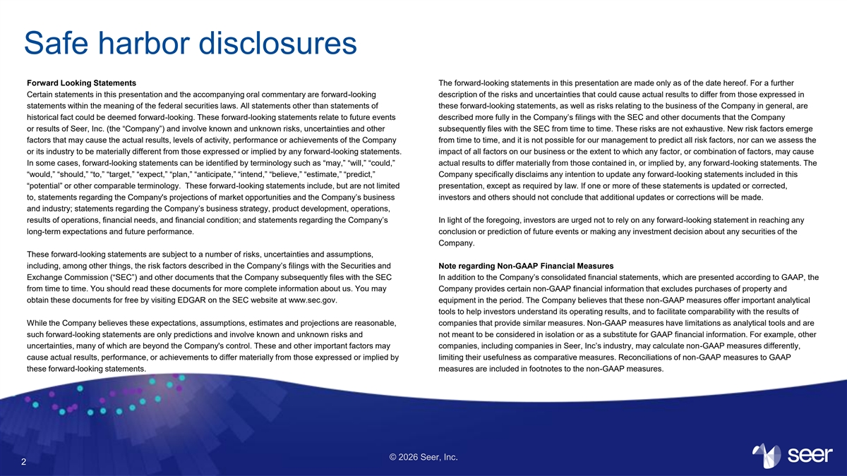
Safe harbor disclosures Forward Looking Statements The forward-looking statements in this presentation are made only as of the date hereof. For a further Certain statements in this presentation and the accompanying oral commentary are forward-looking description of the risks and uncertainties that could cause actual results to differ from those expressed in statements within the meaning of the federal securities laws. All statements other than statements of these forward-looking statements, as well as risks relating to the business of the Company in general, are historical fact could be deemed forward-looking. These forward-looking statements relate to future events described more fully in the Company’s filings with the SEC and other documents that the Company or results of Seer, Inc. (the “Company”) and involve known and unknown risks, uncertainties and other subsequently files with the SEC from time to time. These risks are not exhaustive. New risk factors emerge factors that may cause the actual results, levels of activity, performance or achievements of the Company from time to time, and it is not possible for our management to predict all risk factors, nor can we assess the or its industry to be materially different from those expressed or implied by any forward-looking statements. impact of all factors on our business or the extent to which any factor, or combination of factors, may cause In some cases, forward-looking statements can be identified by terminology such as “may,” “will,” “could,” actual results to differ materially from those contained in, or implied by, any forward-looking statements. The “would,” “should,” “to,” “target,” “expect,” “plan,” “anticipate,” “intend,” “believe,” “estimate,” “predict,” Company specifically disclaims any intention to update any forward-looking statements included in this “potential” or other comparable terminology. These forward-looking statements include, but are not limited presentation, except as required by law. If one or more of these statements is updated or corrected, to, statements regarding the Company's projections of market opportunities and the Company’s business investors and others should not conclude that additional updates or corrections will be made. and industry; statements regarding the Company’s business strategy, product development, operations, results of operations, financial needs, and financial condition; and statements regarding the Company’s In light of the foregoing, investors are urged not to rely on any forward-looking statement in reaching any long-term expectations and future performance. conclusion or prediction of future events or making any investment decision about any securities of the Company. These forward-looking statements are subject to a number of risks, uncertainties and assumptions, including, among other things, the risk factors described in the Company’s filings with the Securities and Note regarding Non-GAAP Financial Measures Exchange Commission (“SEC”) and other documents that the Company subsequently files with the SEC In addition to the Company’s consolidated financial statements, which are presented according to GAAP, the from time to time. You should read these documents for more complete information about us. You may Company provides certain non-GAAP financial information that excludes purchases of property and obtain these documents for free by visiting EDGAR on the SEC website at www.sec.gov. equipment in the period. The Company believes that these non-GAAP measures offer important analytical tools to help investors understand its operating results, and to facilitate comparability with the results of While the Company believes these expectations, assumptions, estimates and projections are reasonable, companies that provide similar measures. Non-GAAP measures have limitations as analytical tools and are such forward-looking statements are only predictions and involve known and unknown risks and not meant to be considered in isolation or as a substitute for GAAP financial information. For example, other uncertainties, many of which are beyond the Company's control. These and other important factors may companies, including companies in Seer, Inc’s industry, may calculate non-GAAP measures differently, cause actual results, performance, or achievements to differ materially from those expressed or implied by limiting their usefulness as comparative measures. Reconciliations of non-GAAP measures to GAAP these forward-looking statements. measures are included in footnotes to the non-GAAP measures. © 2026 Seer, Inc. 2

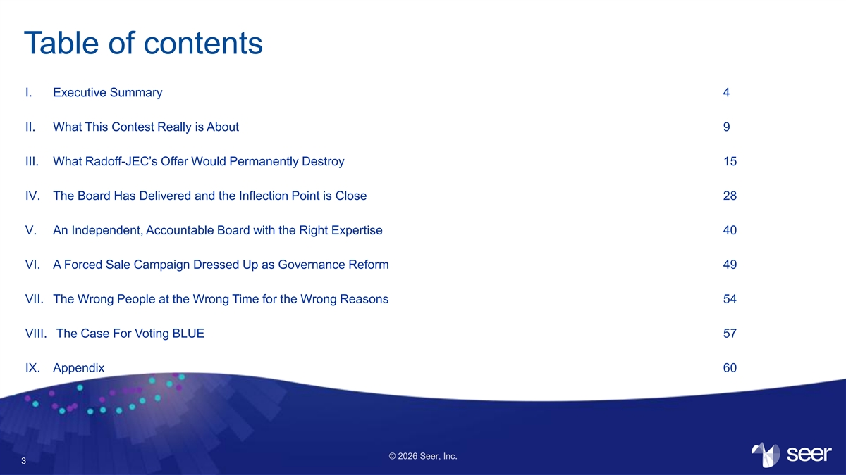
Table of contents I. Executive Summary 4 II. What This Contest Really is About 9 III. What Radoff-JEC’s Offer Would Permanently Destroy 15 IV. The Board Has Delivered and the Inflection Point is Close 28 V. An Independent, Accountable Board with the Right Expertise 40 VI. A Forced Sale Campaign Dressed Up as Governance Reform 49 VII. The Wrong People at the Wrong Time for the Wrong Reasons 54 VIII. The Case For Voting BLUE 57 IX. Appendix 60 © 2026 Seer, Inc. 3

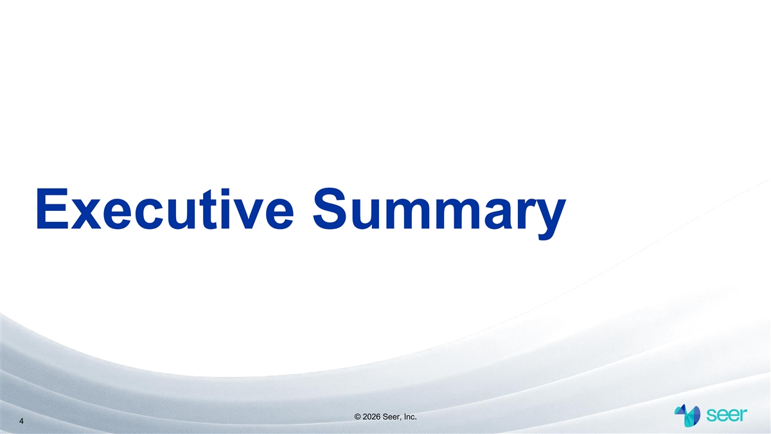
Executive Summary © 2026 Seer, Inc. 4

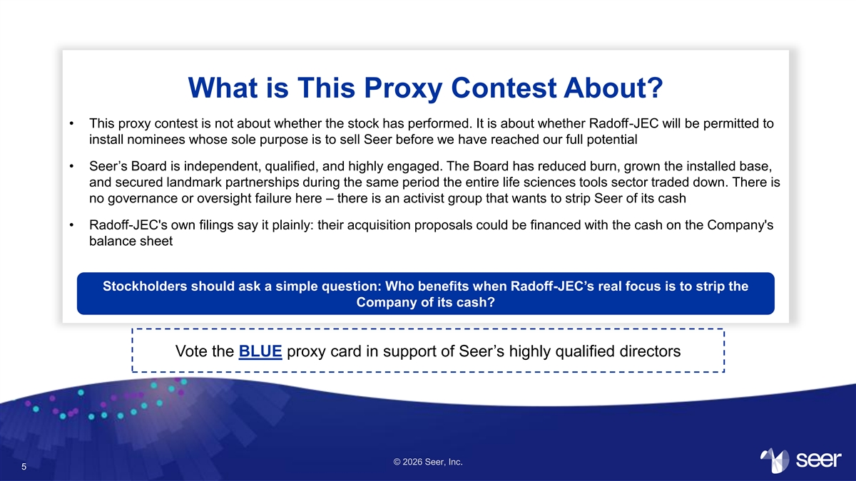
What is This Proxy Contest About? • This proxy contest is not about whether the stock has performed. It is about whether Radoff-JEC will be permitted to install nominees whose sole purpose is to sell Seer before we have reached our full potential • Seer’s Board is independent, qualified, and highly engaged. The Board has reduced burn, grown the installed base, and secured landmark partnerships during the same period the entire life sciences tools sector traded down. There is no governance or oversight failure here – there is an activist group that wants to strip Seer of its cash • Radoff-JEC's own filings say it plainly: their acquisition proposals could be financed with the cash on the Company's balance sheet Stockholders should ask a simple question: Who benefits when Radoff-JEC’s real focus is to strip the Company of its cash? Vote the BLUE proxy card in support of Seer’s highly qualified directors © 2026 Seer, Inc. 5

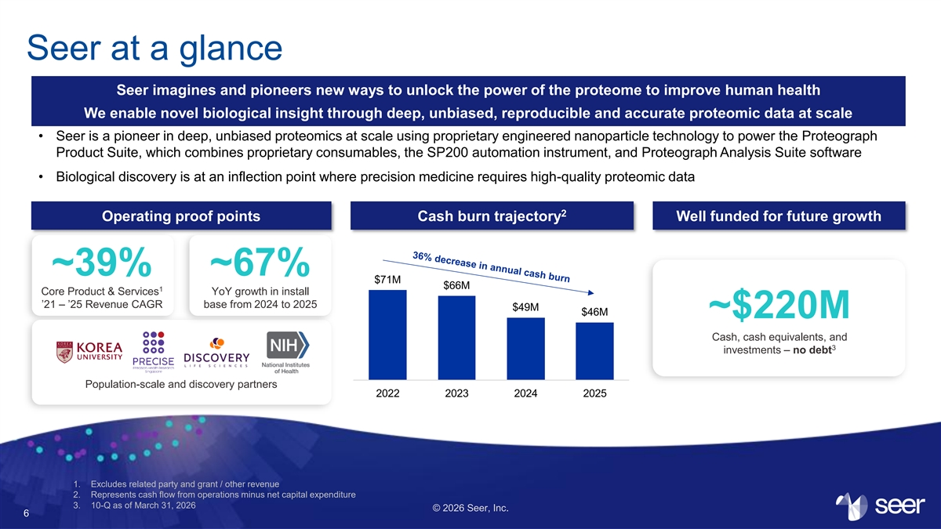
Seer at a glance Seer imagines and pioneers new ways to unlock the power of the proteome to improve human health We enable novel biological insight through deep, unbiased, reproducible and accurate proteomic data at scale • Seer is a pioneer in deep, unbiased proteomics at scale using proprietary engineered nanoparticle technology to power the Proteograph Product Suite, which combines proprietary consumables, the SP200 automation instrument, and Proteograph Analysis Suite software • Biological discovery is at an inflection point where precision medicine requires high-quality proteomic data 2 Operating proof points Cash burn trajectory Well funded for future growth ~39% ~67% $71M $66M 1 Core Product & Services YoY growth in install ’21 – ’25 Revenue CAGR base from 2024 to 2025 $49M $46M ~$220M Cash, cash equivalents, and 3 investments – no debt Population-scale and discovery partners 2022 2023 2024 2025 1. Excludes related party and grant / other revenue 2. Represents cash flow from operations minus net capital expenditure 3. 10-Q as of March 31, 2026 © 2026 Seer, Inc. 6

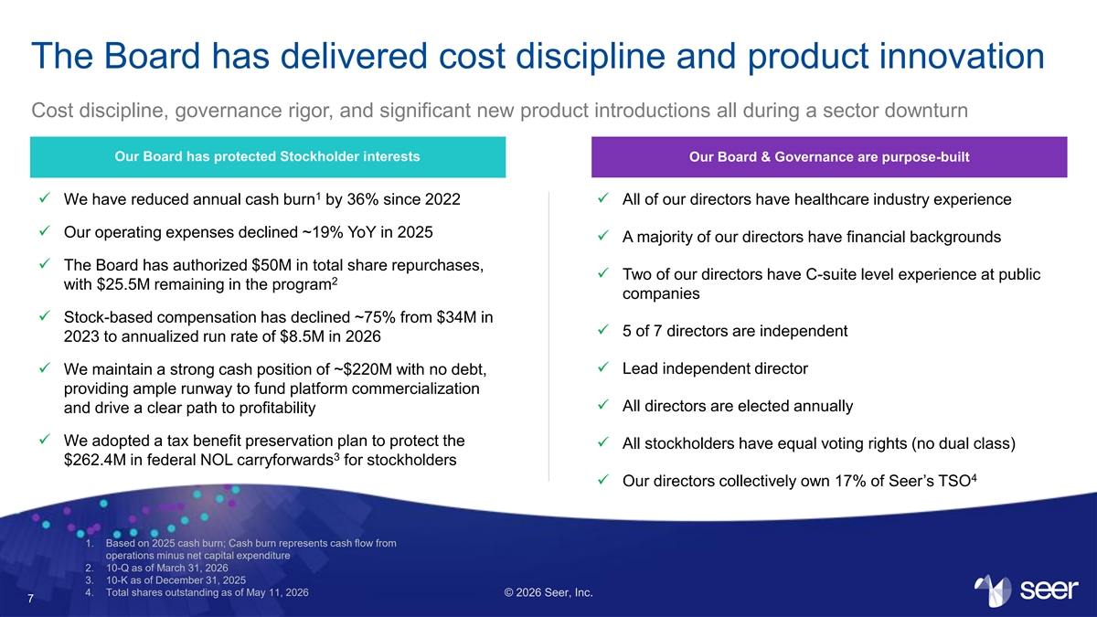
The Board has delivered cost discipline and product innovation Cost discipline, governance rigor, and significant new product introductions all during a sector downturn Our Board has protected Stockholder interests Our Board & Governance are purpose-built 1 ✓ We have reduced annual cash burn by 36% since 2022✓ All of our directors have healthcare industry experience ✓ Our operating expenses declined ~19% YoY in 2025 ✓ A majority of our directors have financial backgrounds ✓ The Board has authorized $50M in total share repurchases, ✓ Two of our directors have C-suite level experience at public 2 with $25.5M remaining in the program companies ✓ Stock-based compensation has declined ~75% from $34M in ✓ 5 of 7 directors are independent 2023 to annualized run rate of $8.5M in 2026 ✓ Lead independent director ✓ We maintain a strong cash position of ~$220M with no debt, providing ample runway to fund platform commercialization ✓ All directors are elected annually and drive a clear path to profitability ✓ We adopted a tax benefit preservation plan to protect the ✓ All stockholders have equal voting rights (no dual class) 3 $262.4M in federal NOL carryforwards for stockholders 4 ✓ Our directors collectively own 17% of Seer’s TSO 1. Based on 2025 cash burn; Cash burn represents cash flow from operations minus net capital expenditure 2. 10-Q as of March 31, 2026 3. 10-K as of December 31, 2025 4. Total shares outstanding as of May 11, 2026 © 2026 Seer, Inc. 7

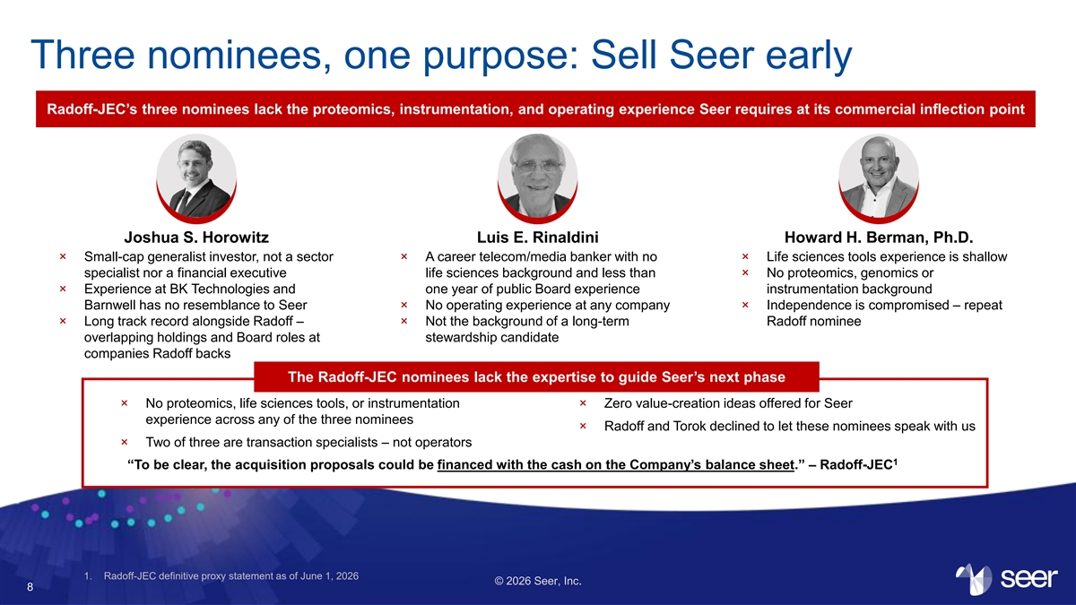
Three nominees, one purpose: Sell Seer early Radoff-JEC’s three nominees lack the proteomics, instrumentation, and operating experience Seer requires at its commercial inflection point Joshua S. Horowitz Luis E. Rinaldini Howard H. Berman, Ph.D. × Small-cap generalist investor, not a sector × A career telecom/media banker with no × Life sciences tools experience is shallow specialist nor a financial executive life sciences background and less than × No proteomics, genomics or × Experience at BK Technologies and one year of public Board experience instrumentation background Barnwell has no resemblance to Seer × No operating experience at any company × Independence is compromised – repeat × Long track record alongside Radoff – × Not the background of a long-term Radoff nominee overlapping holdings and Board roles at stewardship candidate companies Radoff backs The Radoff-JEC nominees lack the expertise to guide Seer’s next phase × No proteomics, life sciences tools, or instrumentation × Zero value-creation ideas offered for Seer experience across any of the three nominees × Radoff and Torok declined to let these nominees speak with us × Two of three are transaction specialists – not operators 1 “To be clear, the acquisition proposals could be financed with the cash on the Company’s balance sheet.” – Radoff-JEC 1. Radoff-JEC definitive proxy statement as of June 1, 2026 © 2026 Seer, Inc. 8


What This Contest Really is About Change is Not Warranted © 2026 Seer, Inc. 9

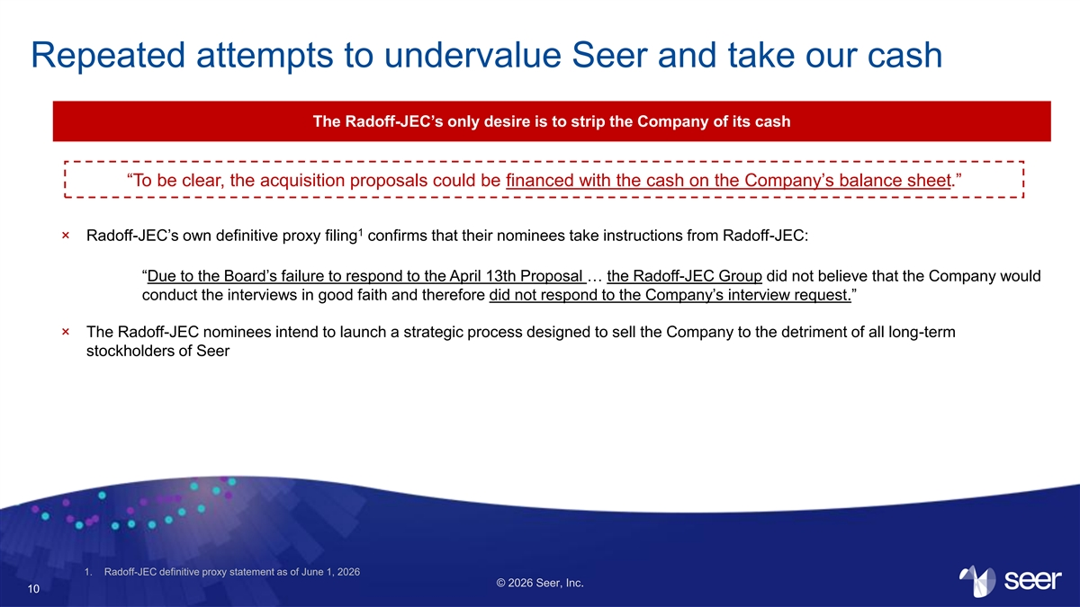
Repeated attempts to undervalue Seer and take our cash The Radoff-JEC’s only desire is to strip the Company of its cash “To be clear, the acquisition proposals could be financed with the cash on the Company’s balance sheet.” 1 × Radoff-JEC’s own definitive proxy filing confirms that their nominees take instructions from Radoff-JEC: “Due to the Board’s failure to respond to the April 13th Proposal … the Radoff-JEC Group did not believe that the Company would conduct the interviews in good faith and therefore did not respond to the Company’s interview request.” × The Radoff-JEC nominees intend to launch a strategic process designed to sell the Company to the detriment of all long-term stockholders of Seer 1. Radoff-JEC definitive proxy statement as of June 1, 2026 © 2026 Seer, Inc. 10

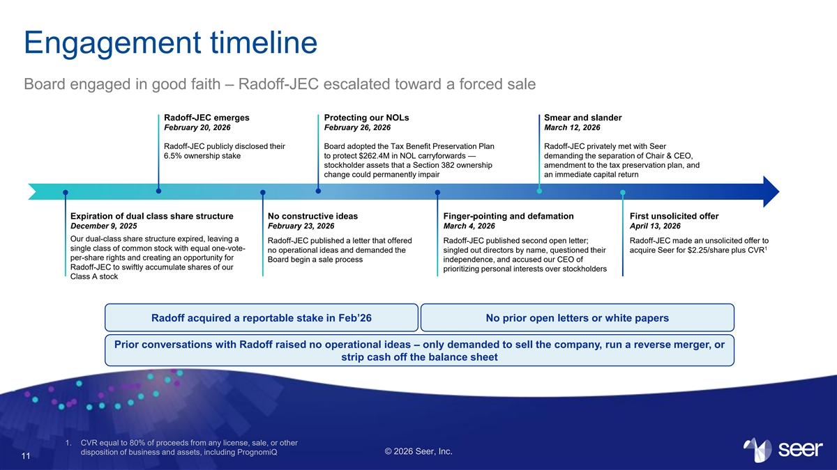
Engagement timeline Board engaged in good faith – Radoff-JEC escalated toward a forced sale Radoff-JEC emerges Protecting our NOLs Smear and slander February 20, 2026 February 26, 2026 March 12, 2026 Radoff-JEC publicly disclosed their Board adopted the Tax Benefit Preservation Plan Radoff-JEC privately met with Seer 6.5% ownership stake to protect $262.4M in NOL carryforwards — demanding the separation of Chair & CEO, stockholder assets that a Section 382 ownership amendment to the tax preservation plan, and change could permanently impair an immediate capital return Expiration of dual class share structure No constructive ideas Finger-pointing and defamation First unsolicited offer December 9, 2025 February 23, 2026 March 4, 2026 April 13, 2026 Our dual-class share structure expired, leaving a Radoff-JEC published a letter that offered Radoff-JEC published second open letter; Radoff-JEC made an unsolicited offer to single class of common stock with equal one-vote- 1 no operational ideas and demanded the singled out directors by name, questioned their acquire Seer for $2.25/share plus CVR per-share rights and creating an opportunity for Board begin a sale process independence, and accused our CEO of Radoff-JEC to swiftly accumulate shares of our prioritizing personal interests over stockholders Class A stock Radoff acquired a reportable stake in Feb’26 No prior open letters or white papers Prior conversations with Radoff raised no operational ideas – only demanded to sell the company, run a reverse merger, or strip cash off the balance sheet 1. CVR equal to 80% of proceeds from any license, sale, or other © 2026 Seer, Inc. disposition of business and assets, including PrognomiQ 11

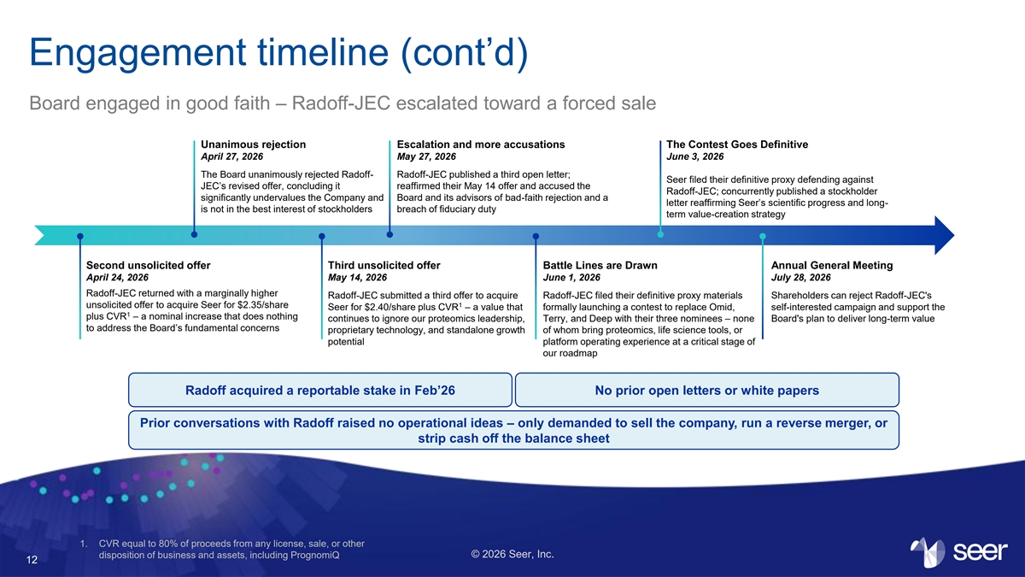
Engagement timeline (cont’d) Board engaged in good faith – Radoff-JEC escalated toward a forced sale Unanimous rejection Escalation and more accusations The Contest Goes Definitive April 27, 2026 May 27, 2026 June 3, 2026 The Board unanimously rejected Radoff- Radoff-JEC published a third open letter; Seer filed their definitive proxy defending against JEC’s revised offer, concluding it reaffirmed their May 14 offer and accused the Radoff-JEC; concurrently published a stockholder significantly undervalues the Company and Board and its advisors of bad-faith rejection and a letter reaffirming Seer’s scientific progress and long- is not in the best interest of stockholders breach of fiduciary duty term value-creation strategy Second unsolicited offer Third unsolicited offer Battle Lines are Drawn Annual General Meeting April 24, 2026 May 14, 2026 June 1, 2026 July 28, 2026 Radoff-JEC returned with a marginally higher Radoff-JEC submitted a third offer to acquire Radoff-JEC filed their definitive proxy materials Shareholders can reject Radoff-JEC's unsolicited offer to acquire Seer for $2.35/share 1 Seer for $2.40/share plus CVR – a value that formally launching a contest to replace Omid, self-interested campaign and support the 1 plus CVR – a nominal increase that does nothing continues to ignore our proteomics leadership, Terry, and Deep with their three nominees – none Board's plan to deliver long-term value to address the Board’s fundamental concerns proprietary technology, and standalone growth of whom bring proteomics, life science tools, or potential platform operating experience at a critical stage of our roadmap Radoff acquired a reportable stake in Feb’26 No prior open letters or white papers Prior conversations with Radoff raised no operational ideas – only demanded to sell the company, run a reverse merger, or strip cash off the balance sheet 1. CVR equal to 80% of proceeds from any license, sale, or other © 2026 Seer, Inc. disposition of business and assets, including PrognomiQ 12

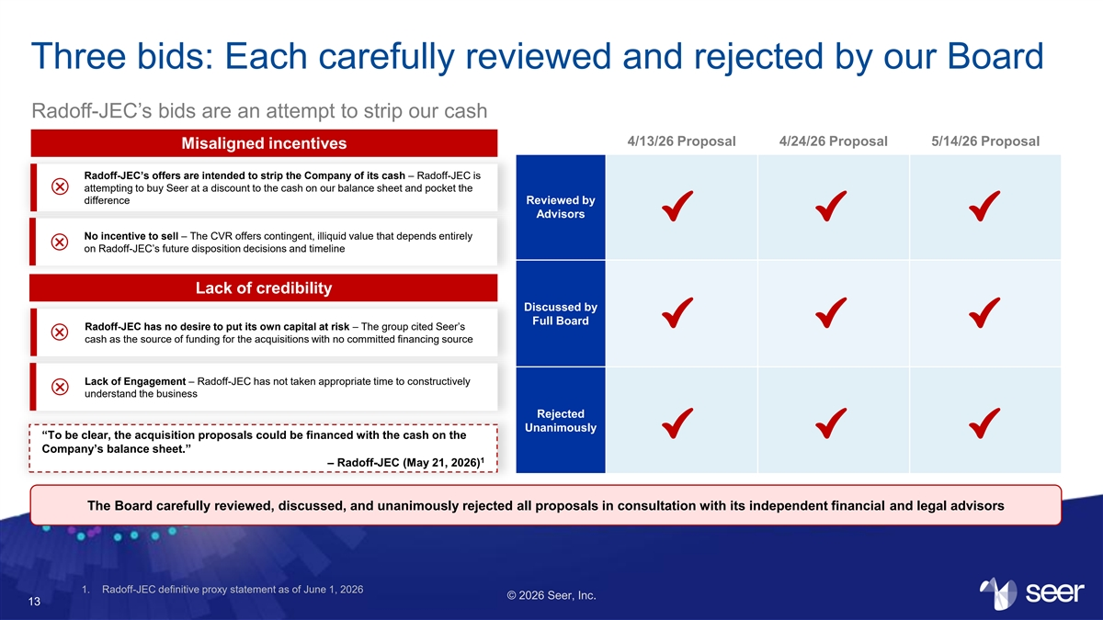
Three bids: Each carefully reviewed and rejected by our Board Radoff-JEC’s bids are an attempt to strip our cash 4/13/26 Proposal 4/24/26 Proposal 5/14/26 Proposal Misaligned incentives Radoff-JEC’s offers are intended to strip the Company of its cash – Radoff-JEC is attempting to buy Seer at a discount to the cash on our balance sheet and pocket the × difference Reviewed by Advisors No incentive to sell – The CVR offers contingent, illiquid value that depends entirely × on Radoff-JEC’s future disposition decisions and timeline Lack of credibility Discussed by Full Board Radoff-JEC has no desire to put its own capital at risk – The group cited Seer’s × cash as the source of funding for the acquisitions with no committed financing source Lack of Engagement – Radoff-JEC has not taken appropriate time to constructively × understand the business Rejected Unanimously “To be clear, the acquisition proposals could be financed with the cash on the Company’s balance sheet.” 1 – Radoff-JEC (May 21, 2026) The Board carefully reviewed, discussed, and unanimously rejected all proposals in consultation with its independent financial and legal advisors 1. Radoff-JEC definitive proxy statement as of June 1, 2026 © 2026 Seer, Inc. 13

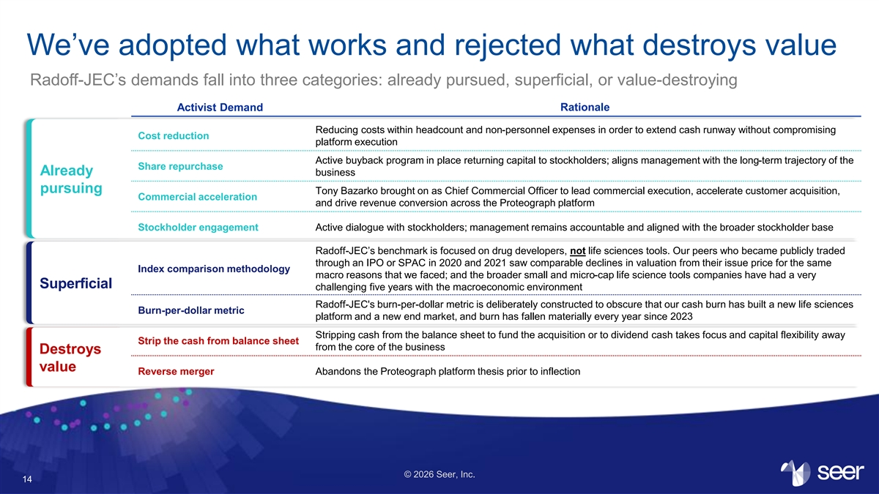
We’ve adopted what works and rejected what destroys value Radoff-JEC’s demands fall into three categories: already pursued, superficial, or value-destroying Rationale Activist Demand Reducing costs within headcount and non-personnel expenses in order to extend cash runway without compromising Cost reduction platform execution Active buyback program in place returning capital to stockholders; aligns management with the long-term trajectory of the Share repurchase Already business pursuing Tony Bazarko brought on as Chief Commercial Officer to lead commercial execution, accelerate customer acquisition, Commercial acceleration and drive revenue conversion across the Proteograph platform Stockholder engagement Active dialogue with stockholders; management remains accountable and aligned with the broader stockholder base Radoff-JEC’s benchmark is focused on drug developers, not life sciences tools. Our peers who became publicly traded through an IPO or SPAC in 2020 and 2021 saw comparable declines in valuation from their issue price for the same Index comparison methodology macro reasons that we faced; and the broader small and micro-cap life science tools companies have had a very Superficial challenging five years with the macroeconomic environment Radoff-JEC's burn-per-dollar metric is deliberately constructed to obscure that our cash burn has built a new life sciences Burn-per-dollar metric platform and a new end market, and burn has fallen materially every year since 2023 Stripping cash from the balance sheet to fund the acquisition or to dividend cash takes focus and capital flexibility away Strip the cash from balance sheet from the core of the business Destroys value Reverse merger Abandons the Proteograph platform thesis prior to inflection © 2026 Seer, Inc. 14


What Radoff-JEC’s Offer Would Permanently Destroy Introduction to Seer © 2026 Seer, Inc. 15

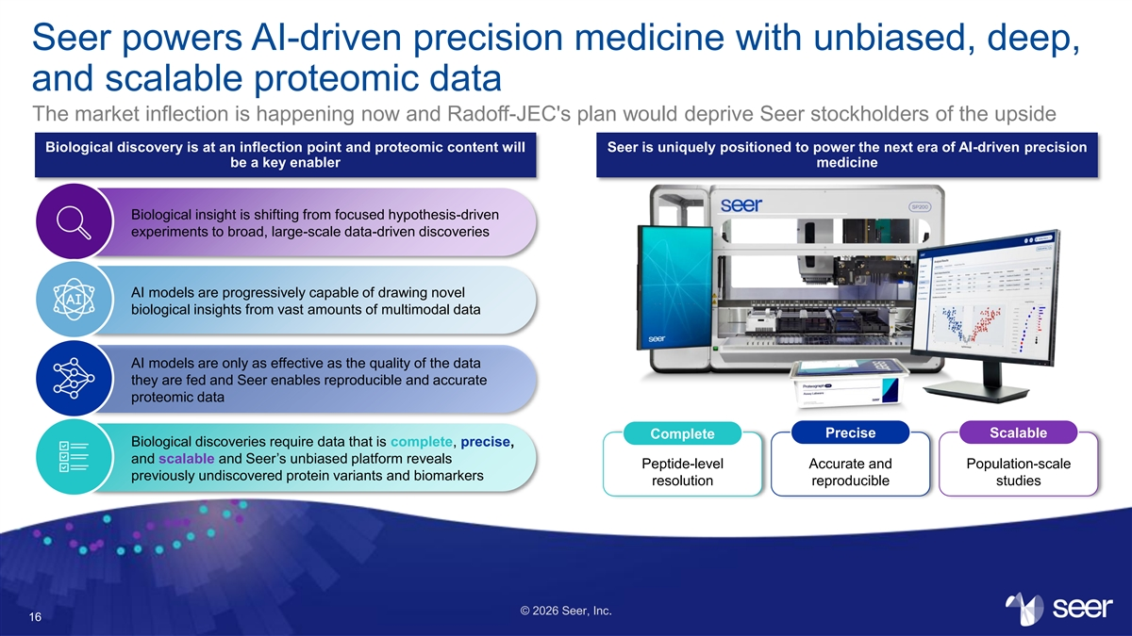
Seer powers AI-driven precision medicine with unbiased, deep, and scalable proteomic data The market inflection is happening now and Radoff-JEC's plan would deprive Seer stockholders of the upside Biological discovery is at an inflection point and proteomic content will Seer is uniquely positioned to power the next era of AI-driven precision be a key enabler medicine Biological insight is shifting from focused hypothesis-driven experiments to broad, large-scale data-driven discoveries AI models are progressively capable of drawing novel biological insights from vast amounts of multimodal data AI models are only as effective as the quality of the data they are fed and Seer enables reproducible and accurate proteomic data Precise Scalable Complete Biological discoveries require data that is complete, precise, and scalable and Seer’s unbiased platform reveals Peptide-level Accurate and Population-scale previously undiscovered protein variants and biomarkers resolution reproducible studies © 2026 Seer, Inc. 16

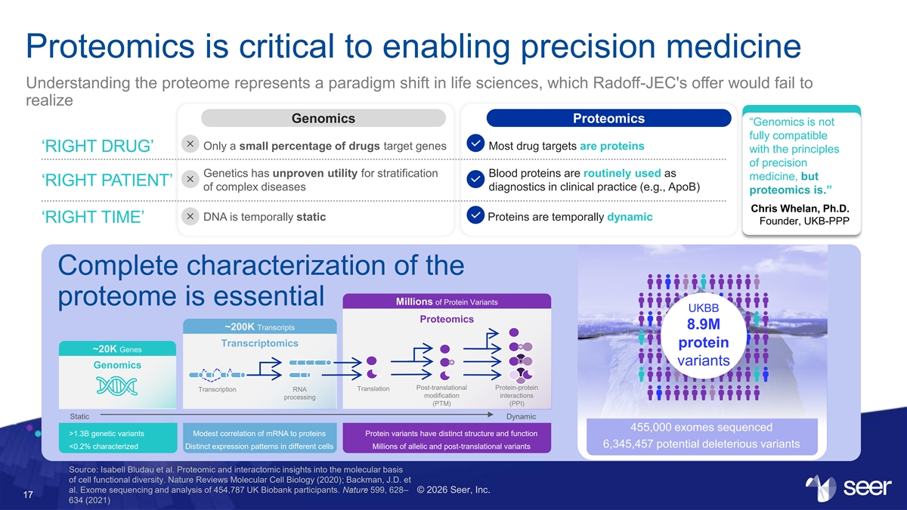
Proteomics is critical to enabling precision medicine Understanding the proteome represents a paradigm shift in life sciences, which Radoff-JEC's offer would fail to realize Genomics Proteomics “Genomics is not fully compatible Only a small percentage of drugs target genes Most drug targets are proteins ‘RIGHT DRUG’ with the principles of precision Genetics has unproven utility for stratification Blood proteins are routinely used as medicine, but ‘RIGHT PATIENT’ of complex diseases diagnostics in clinical practice (e.g., ApoB) proteomics is.” Chris Whelan, Ph.D. DNA is temporally static Proteins are temporally dynamic ‘RIGHT TIME’ Founder, UKB-PPP Complete characterization of the Millions of Protein Variants proteome is essential UKBB Proteomics 8.9M ~200K Transcripts Transcriptomics protein ~20K Genes variants Genomics Post-translational Protein-protein Translation Transcription RNA modification interactions processing (PTM) (PPI) Static Dynamic 455,000 exomes sequenced >1.3B genetic variants Modest correlation of mRNA to proteins Protein variants have distinct structure and function 6,345,457 potential deleterious variants <0.2% characterized Distinct expression patterns in different cells Millions of allelic and post-translational variants Source: Isabell Bludau et al. Proteomic and interactomic insights into the molecular basis of cell functional diversity. Nature Reviews Molecular Cell Biology (2020); Backman, J.D. et al. Exome sequencing and analysis of 454,787 UK Biobank participants. Nature 599, 628– © 2026 Seer, Inc. 17 634 (2021)

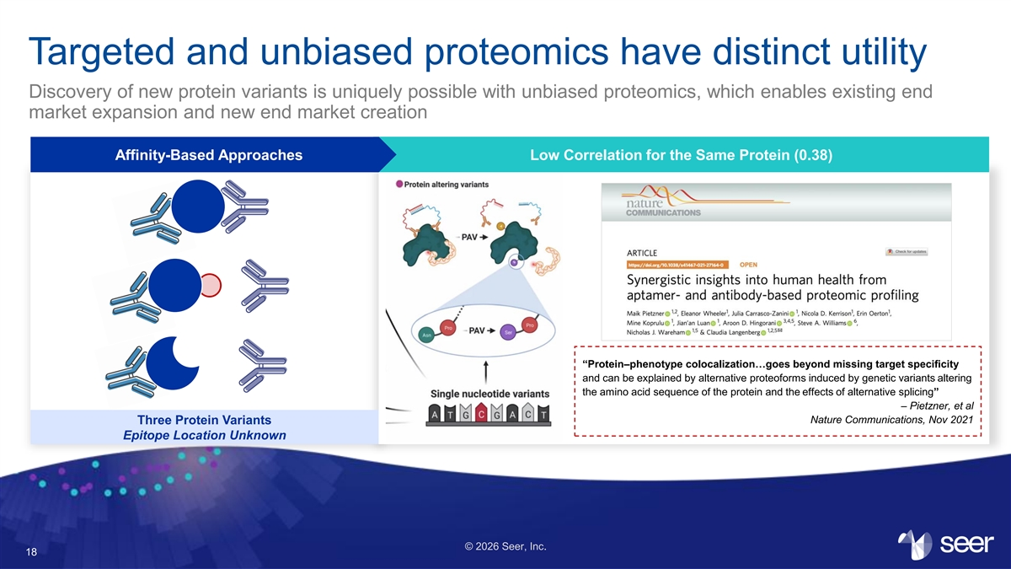
Targeted and unbiased proteomics have distinct utility Discovery of new protein variants is uniquely possible with unbiased proteomics, which enables existing end market expansion and new end market creation Affinity-Based Approaches Low Correlation for the Same Protein (0.38) “Protein–phenotype colocalization…goes beyond missing target speciﬁcity and can be explained by alternative proteoforms induced by genetic variants altering the amino acid sequence of the protein and the effects of alternative splicing” – Pietzner, et al Nature Communications, Nov 2021 Three Protein Variants Epitope Location Unknown © 2026 Seer, Inc. 18

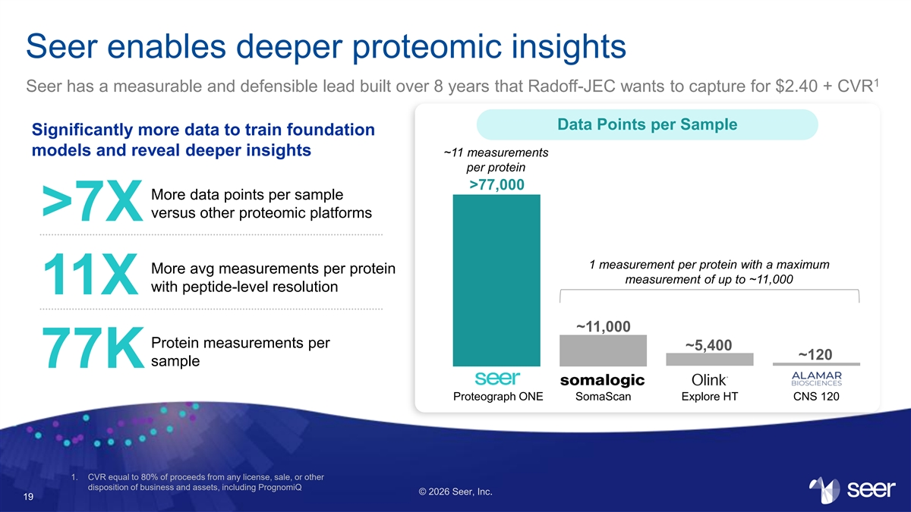
Seer enables deeper proteomic insights 1 Seer has a measurable and defensible lead built over 8 years that Radoff-JEC wants to capture for $2.40 + CVR Data Points per Sample Significantly more data to train foundation models and reveal deeper insights ~11 measurements per protein >77,000 More data points per sample versus other proteomic platforms >7X 1 measurement per protein with a maximum More avg measurements per protein measurement of up to ~11,000 with peptide-level resolution 11X ~11,000 Protein measurements per ~5,400 ~120 sample 77K Proteograph ONE SomaScan Explore HT CNS 120 1. CVR equal to 80% of proceeds from any license, sale, or other disposition of business and assets, including PrognomiQ © 2026 Seer, Inc. 19

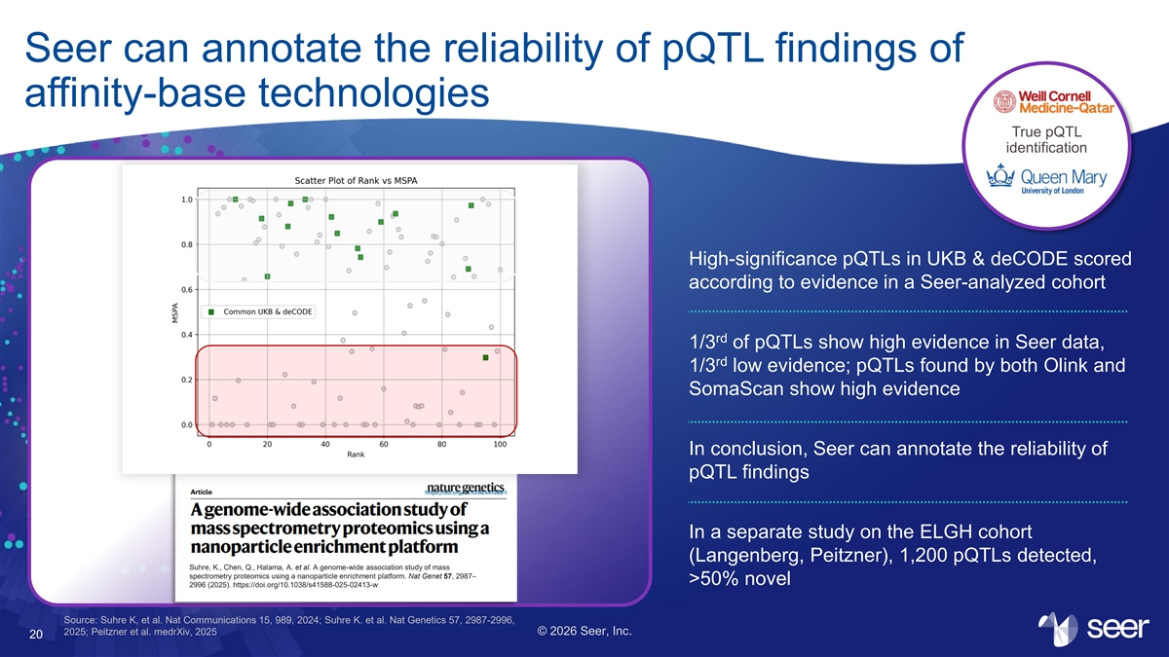
Seer can annotate the reliability of pQTL findings of affinity-base technologies True pQTL identification High-significance pQTLs in UKB & deCODE scored according to evidence in a Seer-analyzed cohort rd 1/3 of pQTLs show high evidence in Seer data, rd 1/3 low evidence; pQTLs found by both Olink and SomaScan show high evidence In conclusion, Seer can annotate the reliability of pQTL findings In a separate study on the ELGH cohort (Langenberg, Peitzner), 1,200 pQTLs detected, Suhre, K., Chen, Q., Halama, A. et al. A genome-wide association study of mass spectrometry proteomics using a nanoparticle enrichment platform. Nat Genet 57, 2987– >50% novel 2996 (2025). https://doi.org/10.1038/s41588-025-02413-w Source: Suhre K, et al. Nat Communications 15, 989, 2024; Suhre K. et al. Nat Genetics 57, 2987-2996, 2025; Peitzner et al. medrXiv, 2025 © 2026 Seer, Inc. 20

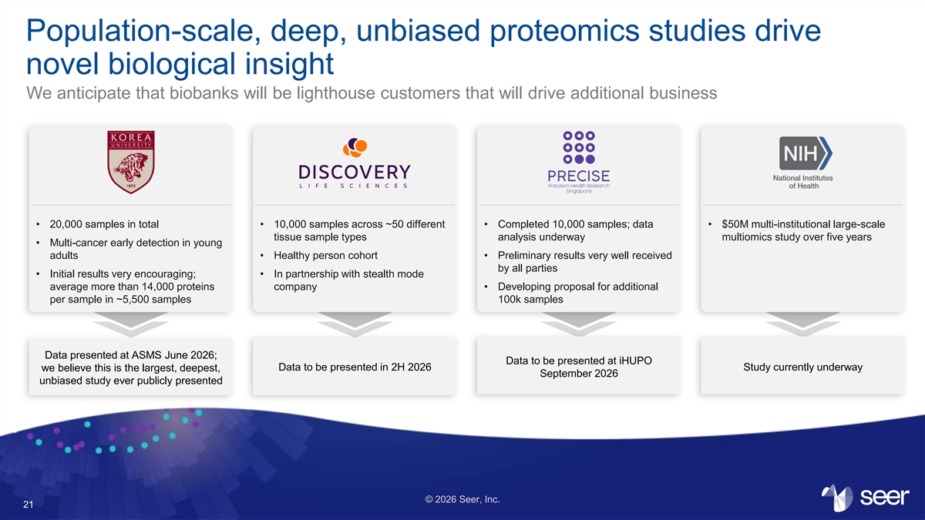
Population-scale, deep, unbiased proteomics studies drive novel biological insight We anticipate that biobanks will be lighthouse customers that will drive additional business • 20,000 samples in total • 10,000 samples across ~50 different • Completed 10,000 samples; data • $50M multi-institutional large-scale tissue sample types analysis underway multiomics study over five years • Multi-cancer early detection in young adults • Healthy person cohort • Preliminary results very well received by all parties • Initial results very encouraging; • In partnership with stealth mode average more than 14,000 proteins company • Developing proposal for additional per sample in ~5,500 samples 100k samples Data presented at ASMS June 2026; Data to be presented at iHUPO Data to be presented in 2H 2026 Study currently underway we believe this is the largest, deepest, September 2026 unbiased study ever publicly presented © 2026 Seer, Inc. 21

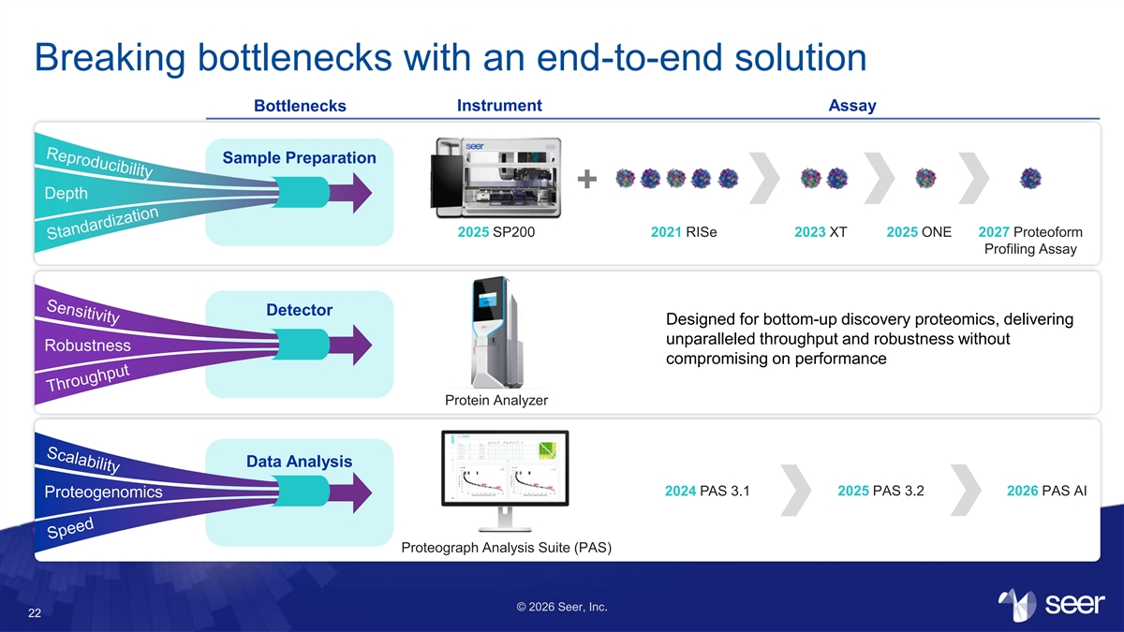
Breaking bottlenecks with an end-to-end solution Bottlenecks Instrument Assay Sample Preparation + Depth 2025 SP200 2021 RISe 2023 XT 2025 ONE 2027 Proteoform Profiling Assay Detector Designed for bottom-up discovery proteomics, delivering unparalleled throughput and robustness without Robustness compromising on performance Protein Analyzer Data Analysis 2024 PAS 3.1 2025 PAS 3.2 2026 PAS AI Proteogenomics Proteograph Analysis Suite (PAS) © 2026 Seer, Inc. 22

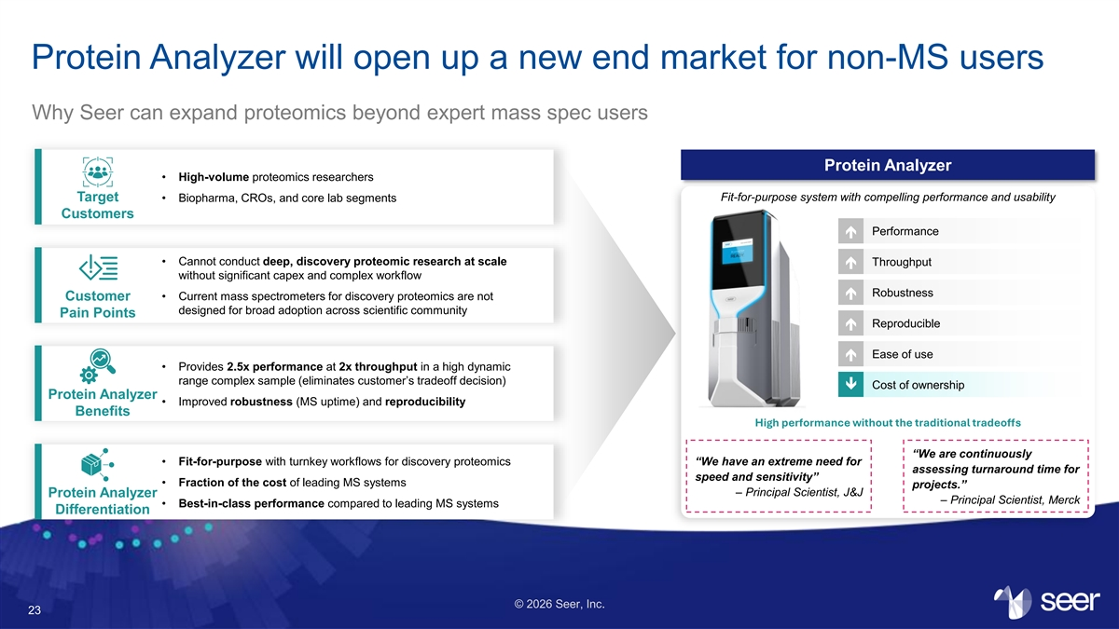
Protein Analyzer will open up a new end market for non-MS users Why Seer can expand proteomics beyond expert mass spec users Protein Analyzer • High-volume proteomics researchers Target • Biopharma, CROs, and core lab segments Fit-for-purpose system with compelling performance and usability Customers Performance é • Cannot conduct deep, discovery proteomic research at scale Throughput é without significant capex and complex workflow Robustness é Customer • Current mass spectrometers for discovery proteomics are not designed for broad adoption across scientific community Pain Points Reproducible é é Ease of use • Provides 2.5x performance at 2x throughput in a high dynamic range complex sample (eliminates customer’s tradeoff decision) Cost of ownership ê Protein Analyzer • Improved robustness (MS uptime) and reproducibility Benefits High performance without the traditional tradeoffs “We are continuously • Fit-for-purpose with turnkey workflows for discovery proteomics “We have an extreme need for assessing turnaround time for speed and sensitivity” • Fraction of the cost of leading MS systems projects.” – Principal Scientist, J&J Protein Analyzer – Principal Scientist, Merck • Best-in-class performance compared to leading MS systems Differentiation © 2026 Seer, Inc. 23

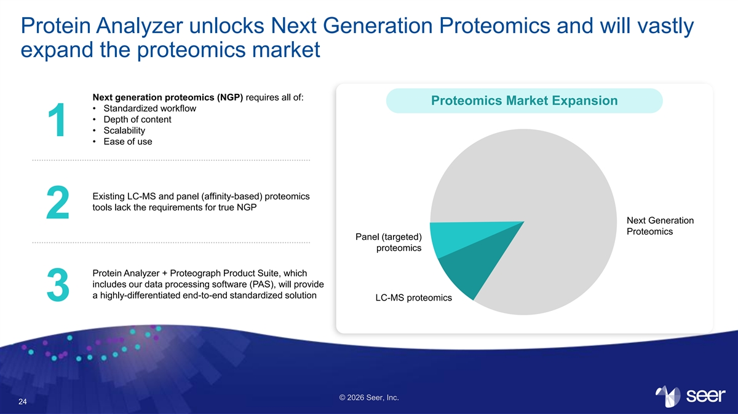
Protein Analyzer unlocks Next Generation Proteomics and will vastly expand the proteomics market Next generation proteomics (NGP) requires all of: Proteomics Market Expansion • Standardized workflow • Depth of content • Scalability 1 • Ease of use Existing LC-MS and panel (affinity-based) proteomics tools lack the requirements for true NGP 2 Next Generation Proteomics Panel (targeted) proteomics Protein Analyzer + Proteograph Product Suite, which includes our data processing software (PAS), will provide a highly-differentiated end-to-end standardized solution LC-MS proteomics 3 © 2026 Seer, Inc. 24

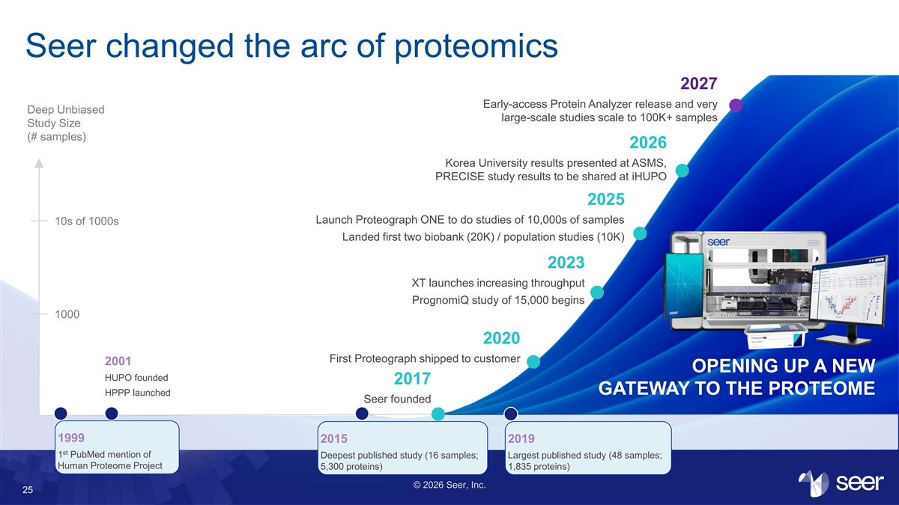
Seer changed the arc of proteomics 2027 Early-access Protein Analyzer release and very Deep Unbiased large-scale studies scale to 100K+ samples Study Size (# samples) 2026 Korea University results presented at ASMS, PRECISE study results to be shared at iHUPO 2025 Launch Proteograph ONE to do studies of 10,000s of samples 10s of 1000s Landed first two biobank (20K) / population studies (10K) 2023 XT launches increasing throughput PrognomiQ study of 15,000 begins 1000 2020 First Proteograph shipped to customer 2001 OPENING UP A NEW HUPO founded 2017 GATEWAY TO THE PROTEOME HPPP launched Seer founded 1999 2015 2019 st 1 PubMed mention of Deepest published study (16 samples; Largest published study (48 samples; Human Proteome Project 5,300 proteins) 1,835 proteins) © 2026 Seer, Inc. 25

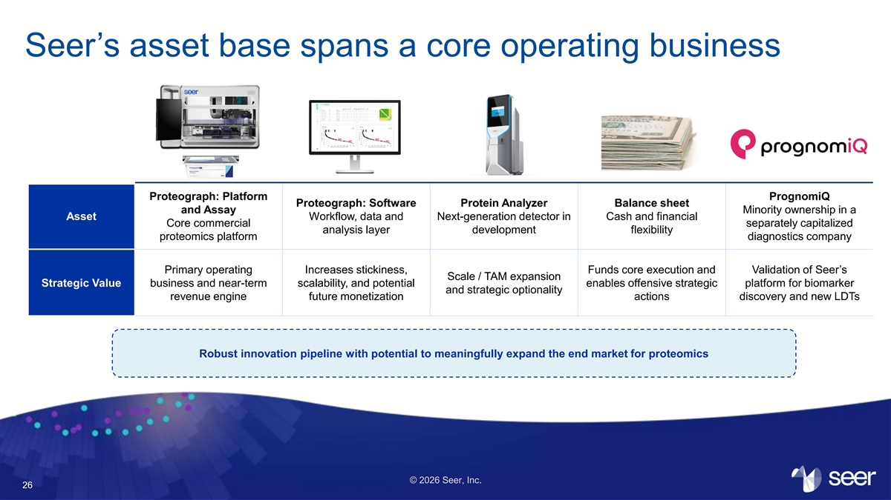
Seer’s asset base spans a core operating business Proteograph: Platform PrognomiQ Proteograph: Software Protein Analyzer Balance sheet and Assay Minority ownership in a Asset Workflow, data and Next-generation detector in Cash and financial Core commercial separately capitalized analysis layer development flexibility proteomics platform diagnostics company Primary operating Increases stickiness, Funds core execution and Validation of Seer’s Scale / TAM expansion Strategic Value business and near-term scalability, and potential enables offensive strategic platform for biomarker and strategic optionality revenue engine future monetization actions discovery and new LDTs Robust innovation pipeline with potential to meaningfully expand the end market for proteomics © 2026 Seer, Inc. 26

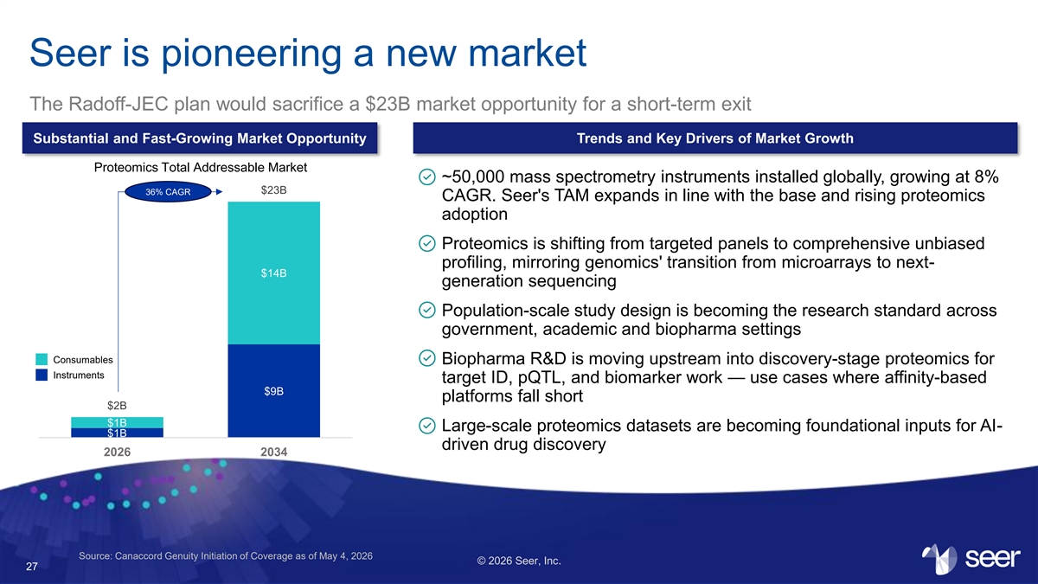
Seer is pioneering a new market The Radoff-JEC plan would sacrifice a $23B market opportunity for a short-term exit Substantial and Fast-Growing Market Opportunity Trends and Key Drivers of Market Growth Proteomics Total Addressable Market ~50,000 mass spectrometry instruments installed globally, growing at 8% $23B 36% CAGR CAGR. Seer's TAM expands in line with the base and rising proteomics adoption Proteomics is shifting from targeted panels to comprehensive unbiased profiling, mirroring genomics' transition from microarrays to next- $14B generation sequencing Population-scale study design is becoming the research standard across government, academic and biopharma settings Consumables Biopharma R&D is moving upstream into discovery-stage proteomics for Instruments target ID, pQTL, and biomarker work — use cases where affinity-based $9B platforms fall short $2B $1B Large-scale proteomics datasets are becoming foundational inputs for AI- $1B driven drug discovery 2026 2034 Source: Canaccord Genuity Initiation of Coverage as of May 4, 2026 © 2026 Seer, Inc. 27

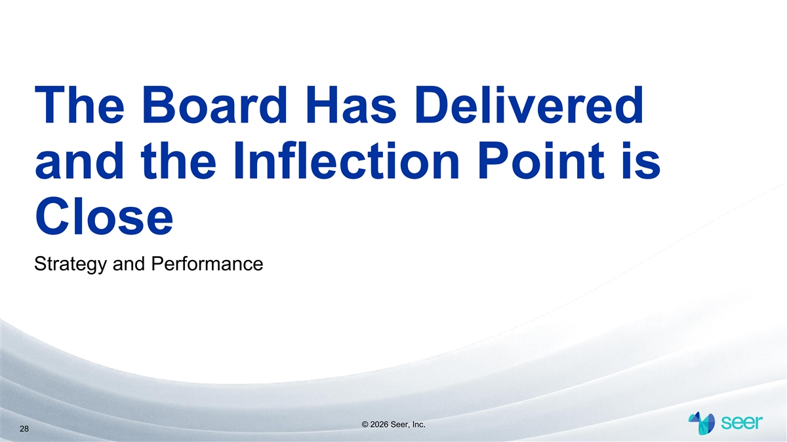
The Board Has Delivered and the Inflection Point is Close Strategy and Performance © 2026 Seer, Inc. 28

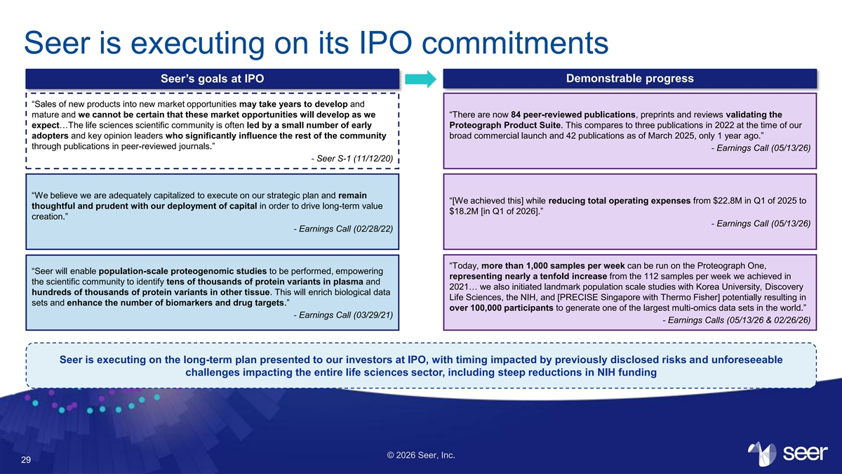
Seer is executing on its IPO commitments Seer’s goals at IPO Demonstrable progress “Sales of new products into new market opportunities may take years to develop and mature and we cannot be certain that these market opportunities will develop as we “There are now 84 peer-reviewed publications, preprints and reviews validating the expect…The life sciences scientific community is often led by a small number of early Proteograph Product Suite. This compares to three publications in 2022 at the time of our adopters and key opinion leaders who significantly influence the rest of the community broad commercial launch and 42 publications as of March 2025, only 1 year ago.” through publications in peer-reviewed journals.” - Earnings Call (05/13/26) - Seer S-1 (11/12/20) “We believe we are adequately capitalized to execute on our strategic plan and remain “[We achieved this] while reducing total operating expenses from $22.8M in Q1 of 2025 to thoughtful and prudent with our deployment of capital in order to drive long-term value $18.2M [in Q1 of 2026].” creation.” - Earnings Call (05/13/26) - Earnings Call (02/28/22) “Today, more than 1,000 samples per week can be run on the Proteograph One, “Seer will enable population-scale proteogenomic studies to be performed, empowering representing nearly a tenfold increase from the 112 samples per week we achieved in the scientific community to identify tens of thousands of protein variants in plasma and 2021… we also initiated landmark population scale studies with Korea University, Discovery hundreds of thousands of protein variants in other tissue. This will enrich biological data Life Sciences, the NIH, and [PRECISE Singapore with Thermo Fisher] potentially resulting in sets and enhance the number of biomarkers and drug targets.” over 100,000 participants to generate one of the largest multi-omics data sets in the world.” - Earnings Call (03/29/21) - Earnings Calls (05/13/26 & 02/26/26) Seer is executing on the long-term plan presented to our investors at IPO, with timing impacted by previously disclosed risks and unforeseeable challenges impacting the entire life sciences sector, including steep reductions in NIH funding © 2026 Seer, Inc. 29

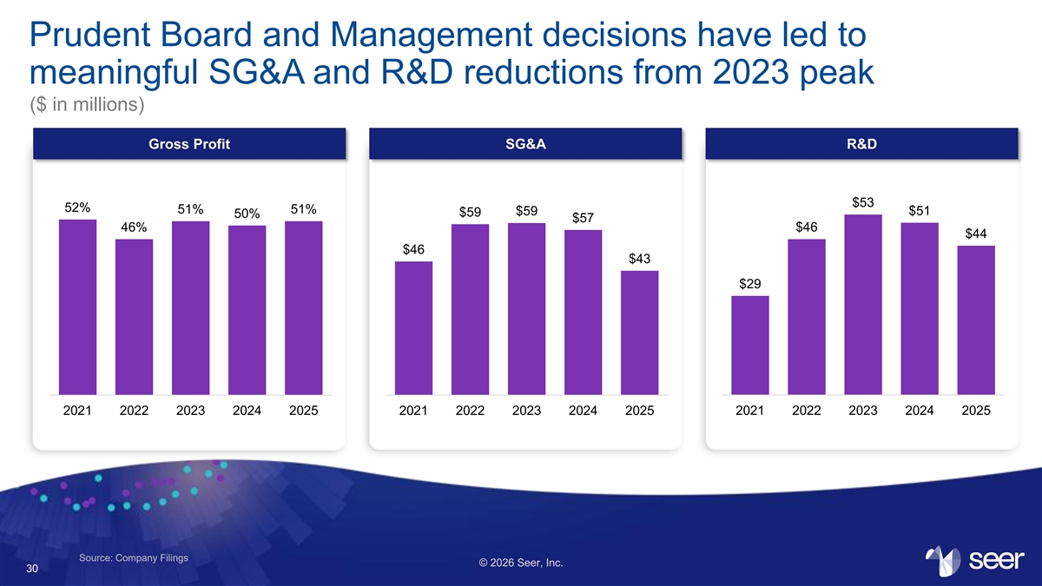
Prudent Board and Management decisions have led to meaningful SG&A and R&D reductions from 2023 peak ($ in millions) Gross Profit SG&A R&D $53 52% 51% 51% $51 $59 $59 50% $57 46% $46 $44 $46 $43 $29 2021 2022 2023 2024 2025 2021 2022 2023 2024 2025 2021 2022 2023 2024 2025 Source: Company Filings © 2026 Seer, Inc. 30

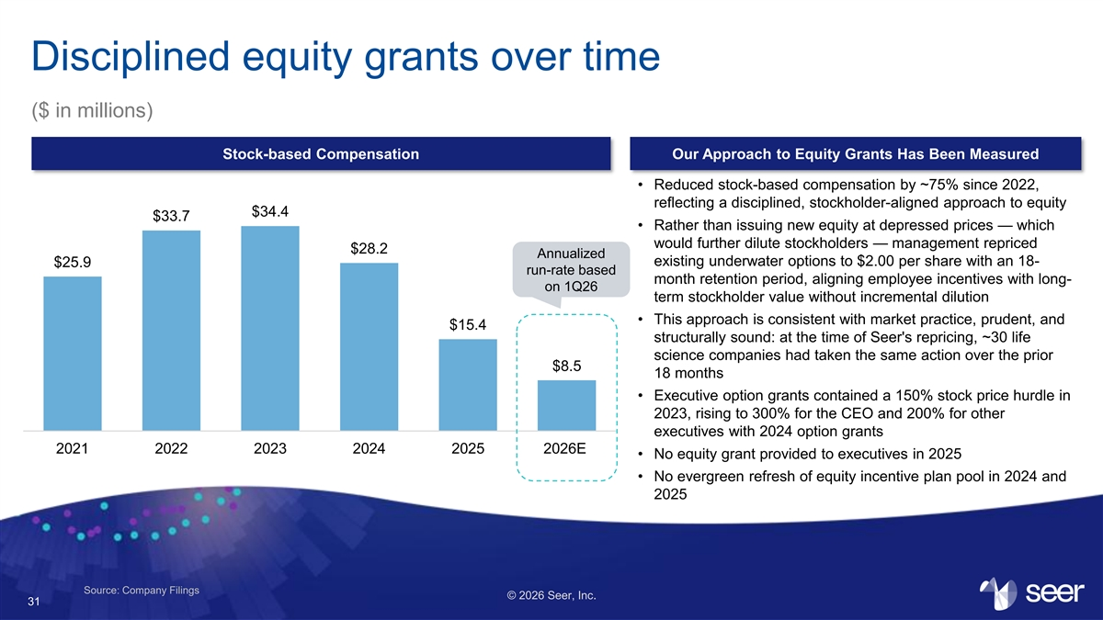
Disciplined equity grants over time ($ in millions) Stock-based Compensation Our Approach to Equity Grants Has Been Measured • Reduced stock-based compensation by ~75% since 2022, reflecting a disciplined, stockholder-aligned approach to equity $34.4 $33.7 • Rather than issuing new equity at depressed prices — which would further dilute stockholders — management repriced $28.2 Annualized existing underwater options to $2.00 per share with an 18- $25.9 run-rate based month retention period, aligning employee incentives with long- on 1Q26 term stockholder value without incremental dilution • This approach is consistent with market practice, prudent, and $15.4 structurally sound: at the time of Seer's repricing, ~30 life science companies had taken the same action over the prior $8.5 18 months • Executive option grants contained a 150% stock price hurdle in 2023, rising to 300% for the CEO and 200% for other executives with 2024 option grants 2021 2022 2023 2024 2025 2026E • No equity grant provided to executives in 2025 • No evergreen refresh of equity incentive plan pool in 2024 and 2025 Source: Company Filings © 2026 Seer, Inc. 31

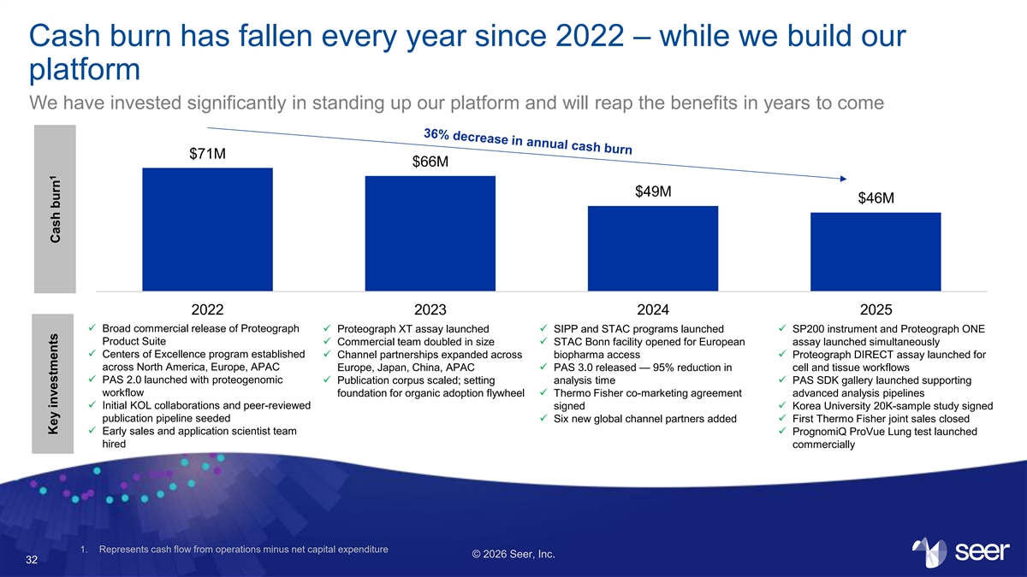
Cash burn has fallen every year since 2022 – while we build our platform We have invested significantly in standing up our platform and will reap the benefits in years to come $71M $66M $49M $46M 2022 2023 2024 2025 ✓ Broad commercial release of Proteograph ✓ Proteograph XT assay launched✓ SIPP and STAC programs launched✓ SP200 instrument and Proteograph ONE Product Suite✓ Commercial team doubled in size✓ STAC Bonn facility opened for European assay launched simultaneously ✓ Centers of Excellence program established ✓ Channel partnerships expanded across biopharma access✓ Proteograph DIRECT assay launched for across North America, Europe, APAC Europe, Japan, China, APAC✓ PAS 3.0 released — 95% reduction in cell and tissue workflows ✓ PAS 2.0 launched with proteogenomic ✓ Publication corpus scaled; setting analysis time✓ PAS SDK gallery launched supporting workflow foundation for organic adoption flywheel✓ Thermo Fisher co-marketing agreement advanced analysis pipelines ✓ Initial KOL collaborations and peer-reviewed signed✓ Korea University 20K-sample study signed publication pipeline seeded✓ Six new global channel partners added✓ First Thermo Fisher joint sales closed ✓ Early sales and application scientist team ✓ PrognomiQ ProVue Lung test launched hired commercially 1. Represents cash flow from operations minus net capital expenditure © 2026 Seer, Inc. 32 1 Key investments Cash burn

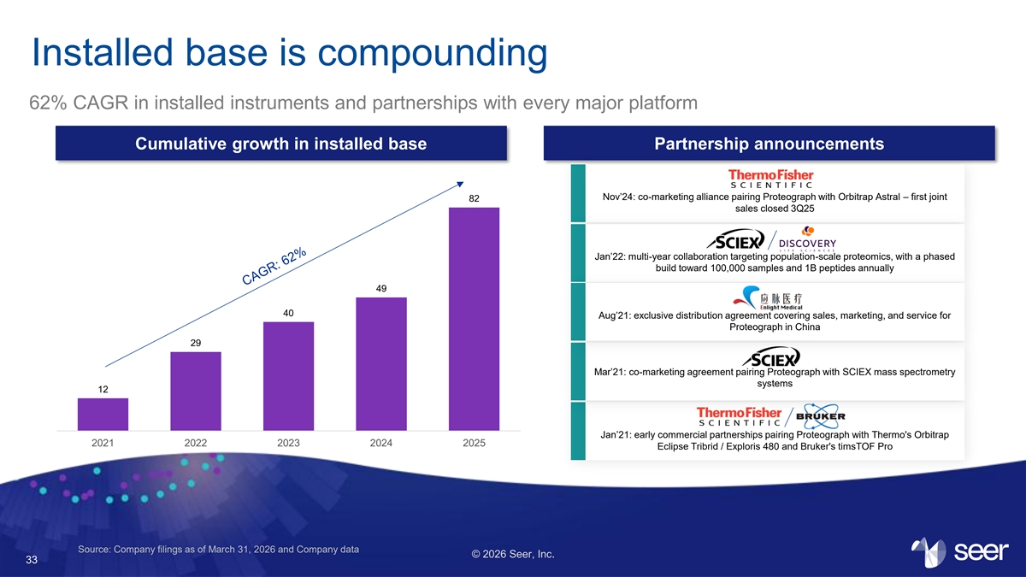
Installed base is compounding 62% CAGR in installed instruments and partnerships with every major platform Cumulative growth in installed base Partnership announcements Nov’24: co-marketing alliance pairing Proteograph with Orbitrap Astral – first joint 82 sales closed 3Q25 Jan’22: multi-year collaboration targeting population-scale proteomics, with a phased build toward 100,000 samples and 1B peptides annually 49 40 Aug’21: exclusive distribution agreement covering sales, marketing, and service for Proteograph in China 29 Mar’21: co-marketing agreement pairing Proteograph with SCIEX mass spectrometry systems 12 Jan’21: early commercial partnerships pairing Proteograph with Thermo's Orbitrap 2021 2022 2023 2024 2025 Eclipse Tribrid / Exploris 480 and Bruker's timsTOF Pro Source: Company filings as of March 31, 2026 and Company data © 2026 Seer, Inc. 33

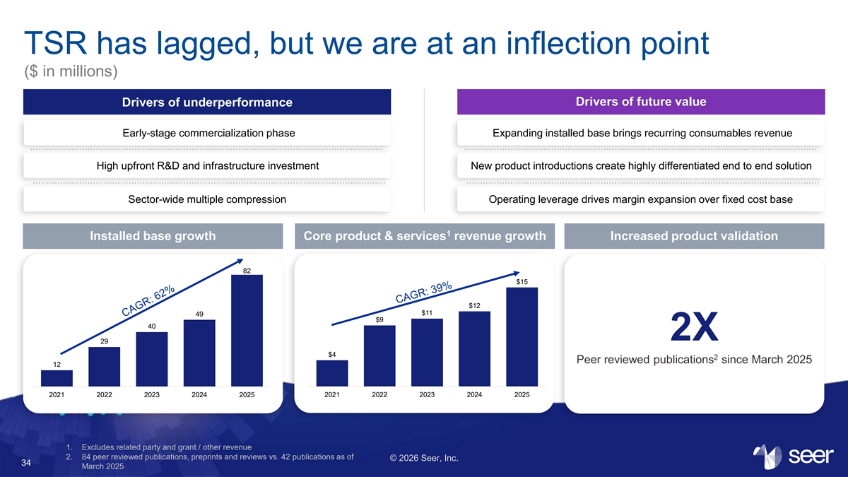
TSR has lagged, but we are at an inflection point ($ in millions) Drivers of future value Drivers of underperformance Early-stage commercialization phase Expanding installed base brings recurring consumables revenue High upfront R&D and infrastructure investment New product introductions create highly differentiated end to end solution Sector-wide multiple compression Operating leverage drives margin expansion over fixed cost base 1 Installed base growth Core product & services revenue growth Increased product validation 82 $15 $12 $11 49 $9 40 v v 2X 29 $4 2 Peer reviewed publications since March 2025 12 2021 2022 2023 2024 2025 2021 2022 2023 2024 2025 1. Excludes related party and grant / other revenue 2. 84 peer reviewed publications, preprints and reviews vs. 42 publications as of © 2026 Seer, Inc. 34 March 2025

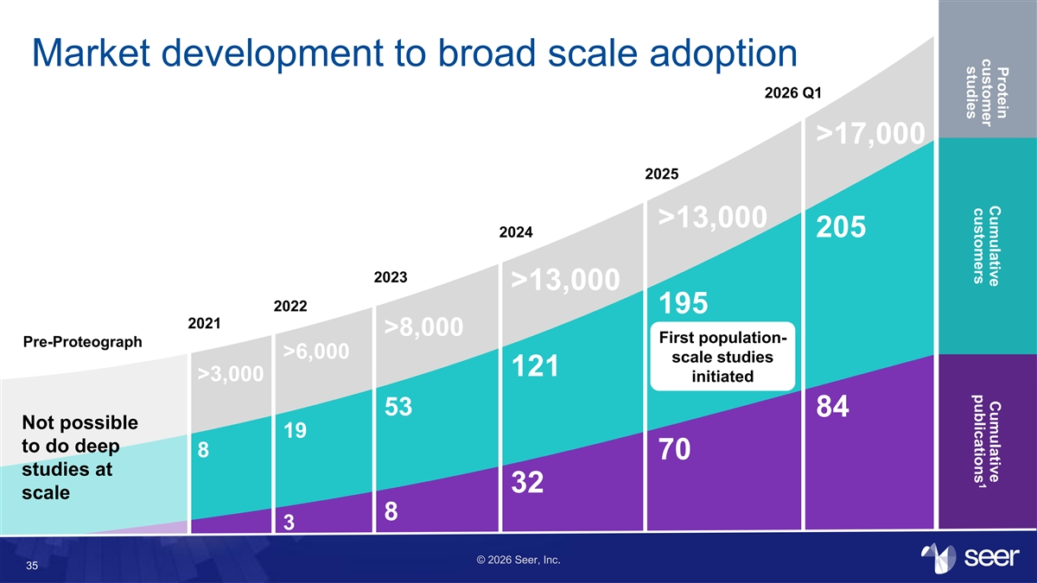
Protein Cumulative Cumulative customer 1 customers publications studies Market development to broad scale adoption 2026 Q1 >17,000 2025 >13,000 2024 205 2023 >13,000 2022 195 2021 >8,000 First population- Pre-Proteograph >6,000 scale studies 121 >3,000 initiated 53 84 Not possible 19 to do deep 8 70 studies at 32 scale 8 3 © 2026 Seer, Inc. 35

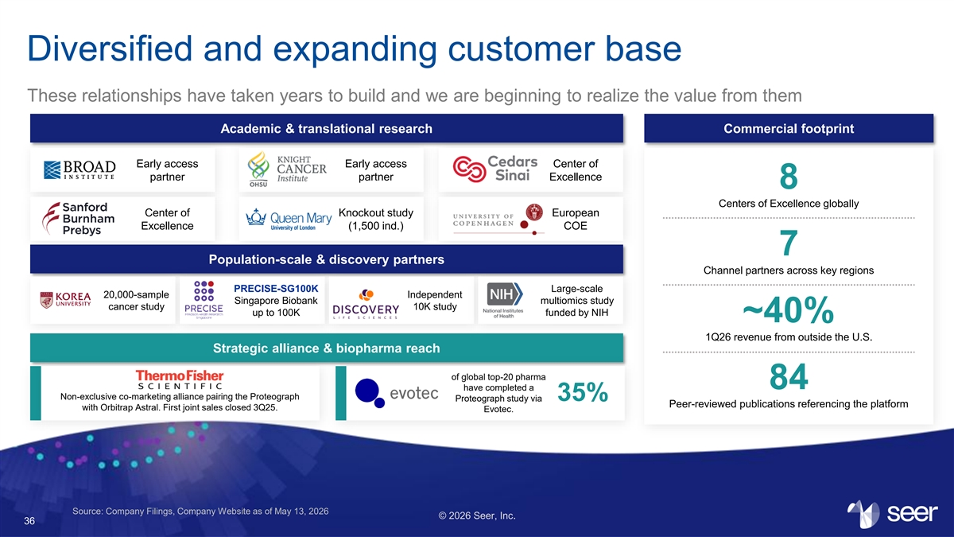
Diversified and expanding customer base These relationships have taken years to build and we are beginning to realize the value from them Academic & translational research Commercial footprint Early access Early access Center of partner partner Excellence 8 Centers of Excellence globally Center of Knockout study European Excellence (1,500 ind.) COE 7 Population-scale & discovery partners Channel partners across key regions PRECISE-SG100K Large-scale 20,000-sample Independent Singapore Biobank multiomics study cancer study 10K study up to 100K funded by NIH ~40% 1Q26 revenue from outside the U.S. Strategic alliance & biopharma reach of global top-20 pharma 84 have completed a Non-exclusive co-marketing alliance pairing the Proteograph 35% Proteograph study via Peer-reviewed publications referencing the platform with Orbitrap Astral. First joint sales closed 3Q25. Evotec. Source: Company Filings, Company Website as of May 13, 2026 © 2026 Seer, Inc. 36

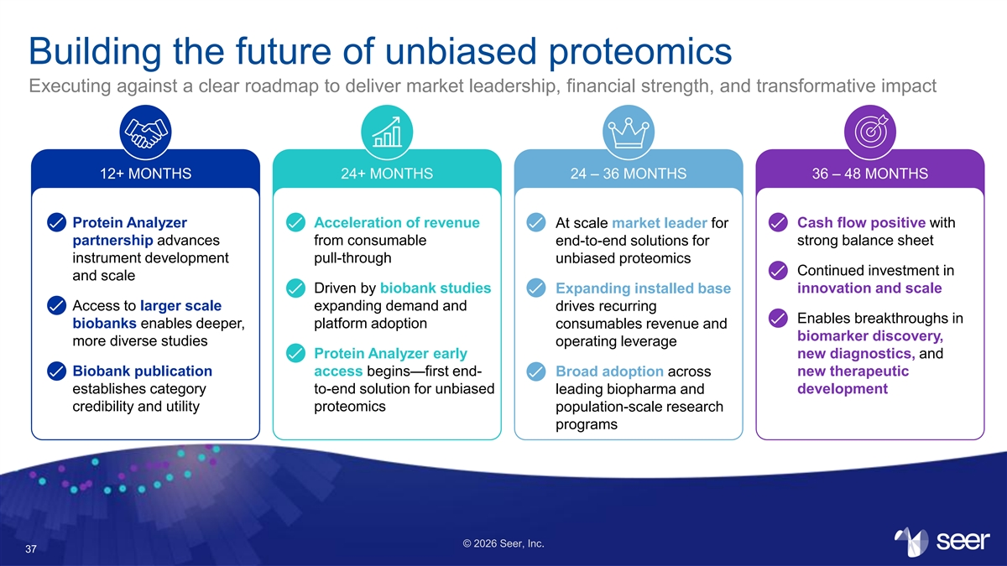
Building the future of unbiased proteomics Executing against a clear roadmap to deliver market leadership, financial strength, and transformative impact 12+ MONTHS 24+ MONTHS 24 – 36 MONTHS 36 – 48 MONTHS Protein Analyzer Acceleration of revenue Cash flow positive with At scale market leader for partnership advances from consumable end-to-end solutions for strong balance sheet instrument development pull-through unbiased proteomics Continued investment in and scale Driven by biobank studies Expanding installed base innovation and scale Access to larger scale expanding demand and drives recurring Enables breakthroughs in biobanks enables deeper, platform adoption consumables revenue and biomarker discovery, more diverse studies operating leverage Protein Analyzer early new diagnostics, and Biobank publication access begins—first end- Broad adoption across new therapeutic establishes category to-end solution for unbiased leading biopharma and development credibility and utility proteomics population-scale research programs © 2026 Seer, Inc. 37

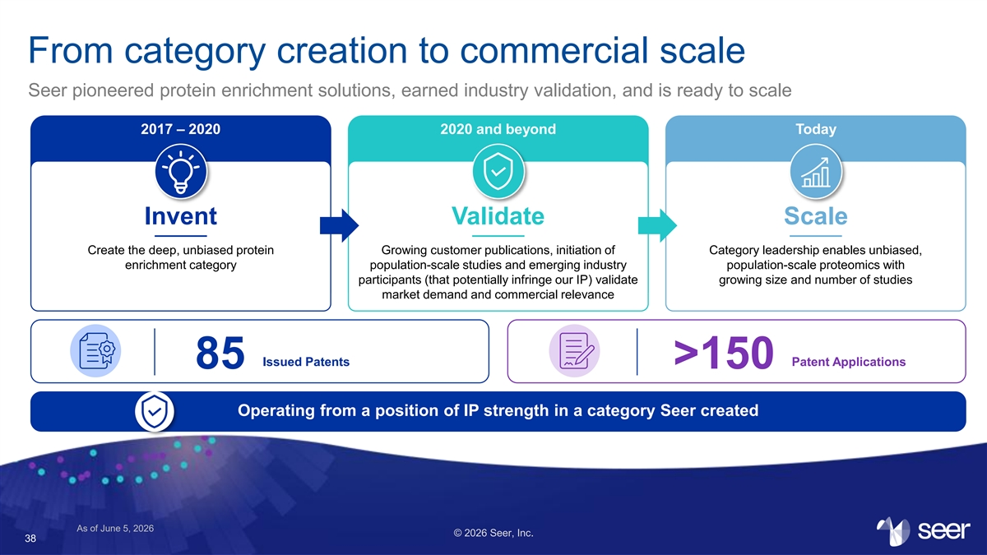
From category creation to commercial scale Seer pioneered protein enrichment solutions, earned industry validation, and is ready to scale 2017 – 2020 2020 and beyond Today Invent Validate Scale Create the deep, unbiased protein Growing customer publications, initiation of Category leadership enables unbiased, enrichment category population-scale studies and emerging industry population-scale proteomics with participants (that potentially infringe our IP) validate growing size and number of studies market demand and commercial relevance Issued Patents Patent Applications 85 >150 Operating from a position of IP strength in a category Seer created As of June 5, 2026 © 2026 Seer, Inc. 38

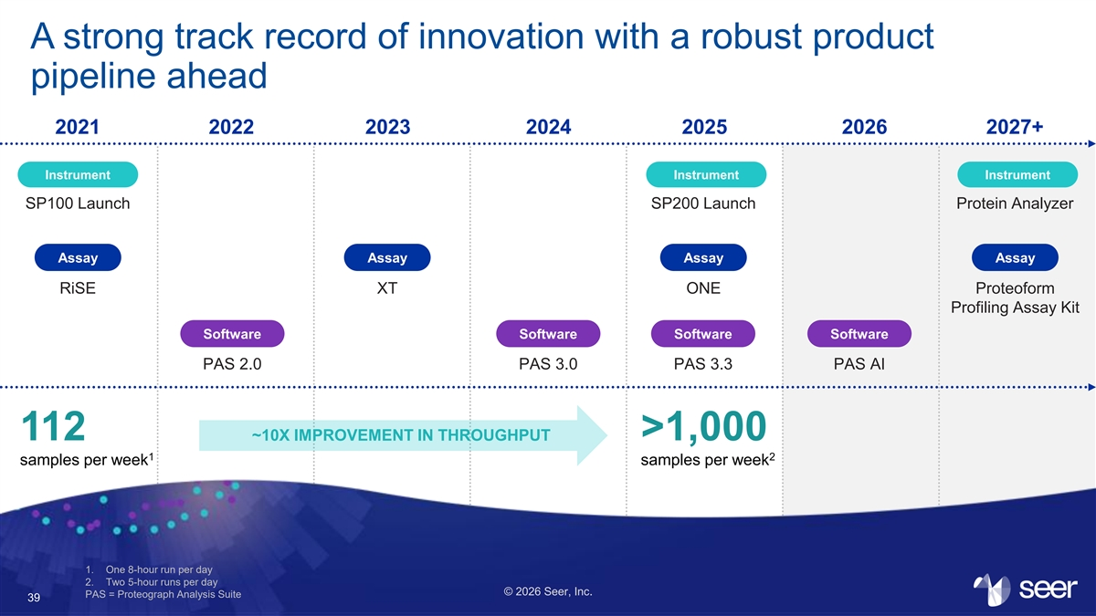
A strong track record of innovation with a robust product pipeline ahead 2021 2022 2023 2024 2025 2026 2027+ Instrument Instrument Instrument SP100 Launch SP200 Launch Protein Analyzer Assay Assay Assay Assay RiSE XT ONE Proteoform Profiling Assay Kit Software Software Software Software PAS 2.0 PAS 3.0 PAS 3.3 PAS AI 112 ~10X IMPROVEMENT IN THROUGHPUT >1,000 1 2 samples per week samples per week 1. One 8-hour run per day 2. Two 5-hour runs per day © 2026 Seer, Inc. PAS = Proteograph Analysis Suite 39

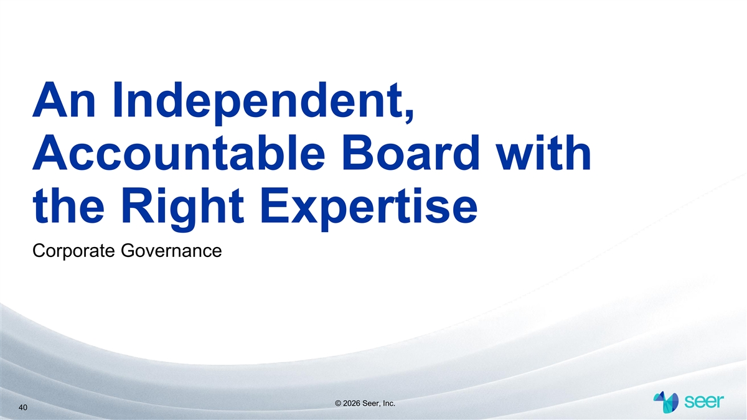
An Independent, Accountable Board with the Right Expertise Corporate Governance © 2026 Seer, Inc. 40

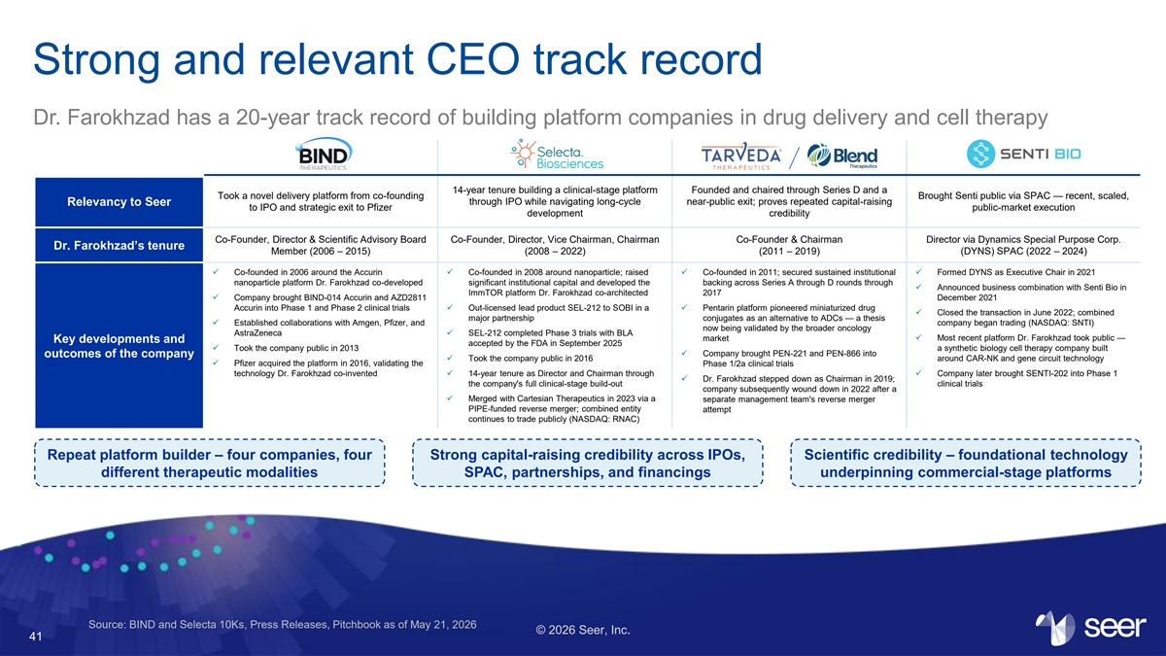
Strong and relevant CEO track record Dr. Farokhzad has a 20-year track record of building platform companies in drug delivery and cell therapy 14-year tenure building a clinical-stage platform Founded and chaired through Series D and a Took a novel delivery platform from co-founding Brought Senti public via SPAC — recent, scaled, through IPO while navigating long-cycle near-public exit; proves repeated capital-raising Relevancy to Seer to IPO and strategic exit to Pfizer public-market execution development credibility Co-Founder, Director & Scientific Advisory Board Co-Founder, Director, Vice Chairman, Chairman Co-Founder & Chairman Director via Dynamics Special Purpose Corp. Dr. Farokhzad’s tenure Member (2006 – 2015) (2008 – 2022) (2011 – 2019) (DYNS) SPAC (2022 – 2024) ✓ Co-founded in 2006 around the Accurin ✓ Co-founded in 2008 around nanoparticle; raised ✓ Co-founded in 2011; secured sustained institutional ✓ Formed DYNS as Executive Chair in 2021 nanoparticle platform Dr. Farokhzad co-developed significant institutional capital and developed the backing across Series A through D rounds through ✓ Announced business combination with Senti Bio in ImmTOR platform Dr. Farokhzad co-architected 2017 ✓ Company brought BIND-014 Accurin and AZD2811 December 2021 Accurin into Phase 1 and Phase 2 clinical trials ✓ Out-licensed lead product SEL-212 to SOBI in a ✓ Pentarin platform pioneered miniaturized drug ✓ Closed the transaction in June 2022; combined major partnership conjugates as an alternative to ADCs — a thesis ✓ Established collaborations with Amgen, Pfizer, and company began trading (NASDAQ: SNTI) now being validated by the broader oncology AstraZeneca✓ SEL-212 completed Phase 3 trials with BLA market✓ Most recent platform Dr. Farokhzad took public — Key developments and accepted by the FDA in September 2025 ✓ Took the company public in 2013 a synthetic biology cell therapy company built ✓ Company brought PEN-221 and PEN-866 into outcomes of the company ✓ Took the company public in 2016 around CAR-NK and gene circuit technology ✓ Pfizer acquired the platform in 2016, validating the Phase 1/2a clinical trials technology Dr. Farokhzad co-invented✓ 14-year tenure as Director and Chairman through ✓ Company later brought SENTI-202 into Phase 1 ✓ Dr. Farokhzad stepped down as Chairman in 2019; the company's full clinical-stage build-out clinical trials company subsequently wound down in 2022 after a ✓ Merged with Cartesian Therapeutics in 2023 via a separate management team's reverse merger PIPE-funded reverse merger; combined entity attempt continues to trade publicly (NASDAQ: RNAC) Repeat platform builder – four companies, four Strong capital-raising credibility across IPOs, Scientific credibility – foundational technology different therapeutic modalities SPAC, partnerships, and financings underpinning commercial-stage platforms Source: BIND and Selecta 10Ks, Press Releases, Pitchbook as of May 21, 2026 © 2026 Seer, Inc. 41

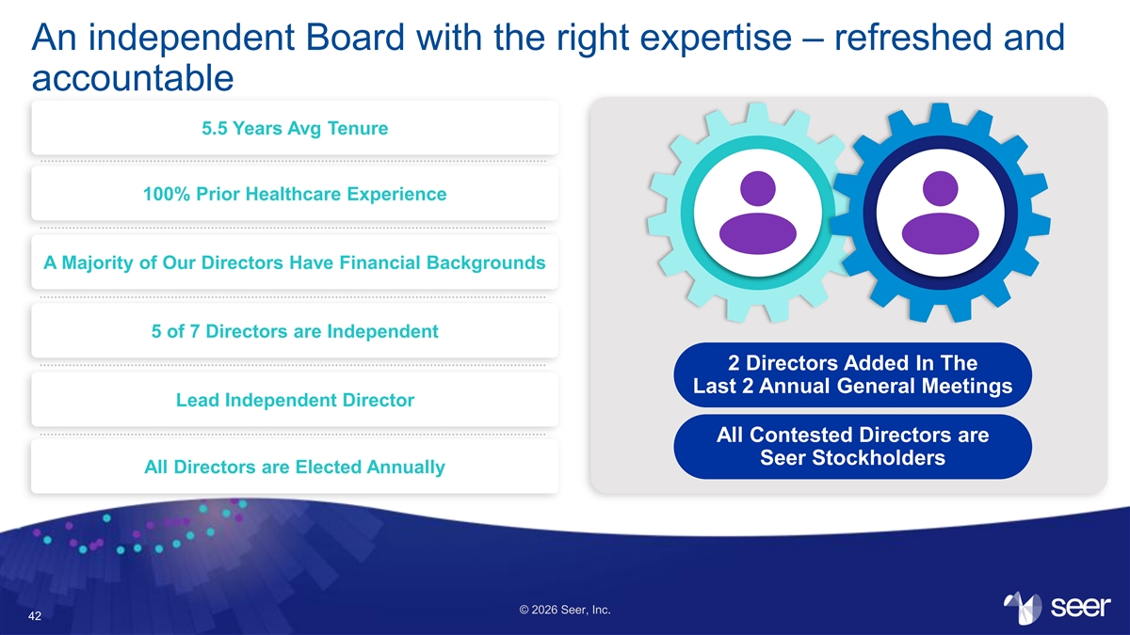
An independent Board with the right expertise – refreshed and accountable 5.5 Years Avg Tenure 100% Prior Healthcare Experience A Majority of Our Directors Have Financial Backgrounds 5 of 7 Directors are Independent 2 Directors Added In The Last 2 Annual General Meetings Lead Independent Director All Contested Directors are Seer Stockholders All Directors are Elected Annually © 2026 Seer, Inc. 42

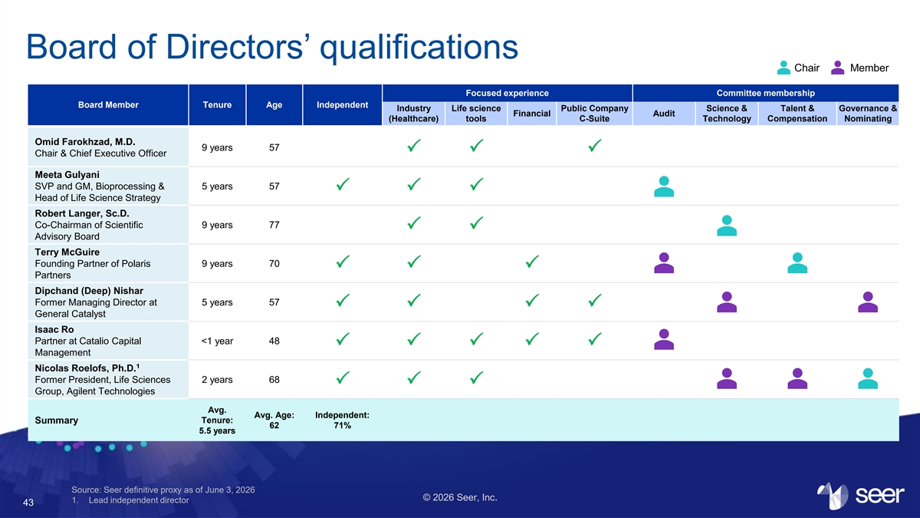
Board of Directors’ qualifications Chair Member Focused experience Committee membership Board Member Tenure Age Independent Industry Life science Public Company Science & Talent & Governance & Financial Audit (Healthcare) tools C-Suite Technology Compensation Nominating Omid Farokhzad, M.D. 9 years 57 PPP Chair & Chief Executive Officer Meeta Gulyani SVP and GM, Bioprocessing & 5 years 57 PPP Head of Life Science Strategy Robert Langer, Sc.D. Co-Chairman of Scientific 9 years 77 PP Advisory Board Terry McGuire Founding Partner of Polaris 9 years 70 PPP Partners Dipchand (Deep) Nishar Former Managing Director at 5 years 57 PPPP General Catalyst Isaac Ro Partner at Catalio Capital <1 year 48 PPPPP Management 1 Nicolas Roelofs, Ph.D. Former President, Life Sciences 2 years 68 PPP Group, Agilent Technologies Avg. Avg. Age: Independent: Tenure: Summary 62 71% 5.5 years Source: Seer definitive proxy as of June 3, 2026 © 2026 Seer, Inc. 1. Lead independent director 43

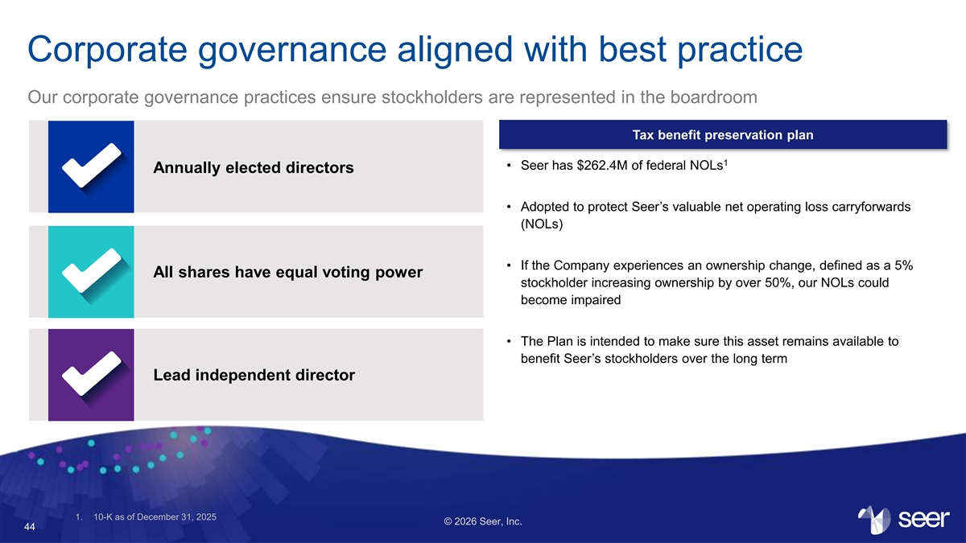
Corporate governance aligned with best practice Our corporate governance practices ensure stockholders are represented in the boardroom Tax benefit preservation plan 1 • Seer has $262.4M of federal NOLs Annually elected directors • Adopted to protect Seer’s valuable net operating loss carryforwards (NOLs) • If the Company experiences an ownership change, defined as a 5% All shares have equal voting power stockholder increasing ownership by over 50%, our NOLs could become impaired • The Plan is intended to make sure this asset remains available to benefit Seer’s stockholders over the long term Lead independent director 1. 10-K as of December 31, 2025 © 2026 Seer, Inc. 44

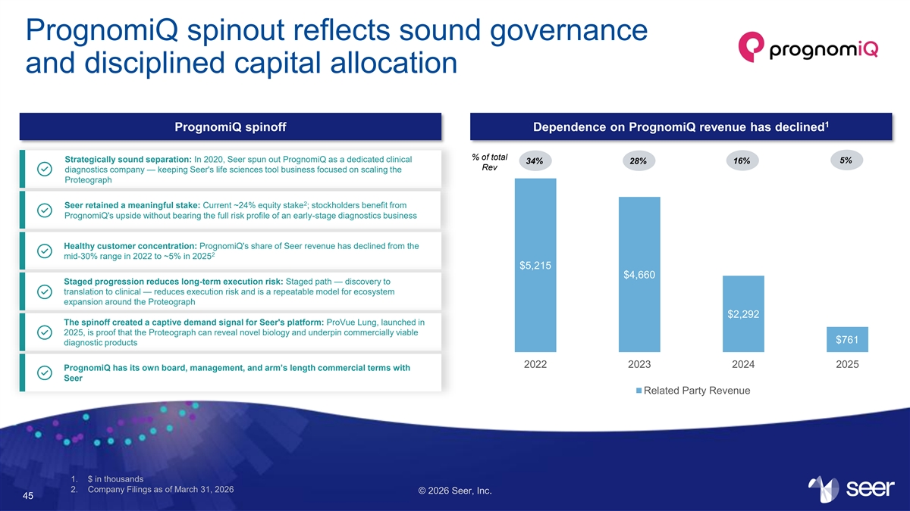
PrognomiQ spinout reflects sound governance and disciplined capital allocation 1 PrognomiQ spinoff Dependence on PrognomiQ revenue has declined % of total Strategically sound separation: In 2020, Seer spun out PrognomiQ as a dedicated clinical 34% 28% 16% 5% Rev diagnostics company — keeping Seer's life sciences tool business focused on scaling the Proteograph 2 Seer retained a meaningful stake: Current ~24% equity stake ; stockholders benefit from PrognomiQ's upside without bearing the full risk profile of an early-stage diagnostics business Healthy customer concentration: PrognomiQ's share of Seer revenue has declined from the 2 mid-30% range in 2022 to ~5% in 2025 $5,215 $4,660 Staged progression reduces long-term execution risk: Staged path — discovery to translation to clinical — reduces execution risk and is a repeatable model for ecosystem expansion around the Proteograph $2,292 The spinoff created a captive demand signal for Seer's platform: ProVue Lung, launched in 2025, is proof that the Proteograph can reveal novel biology and underpin commercially viable $761 diagnostic products 2022 2023 2024 2025 PrognomiQ has its own board, management, and arm’s length commercial terms with Seer Related Party Revenue 1. $ in thousands 2. Company Filings as of March 31, 2026 © 2026 Seer, Inc. 45

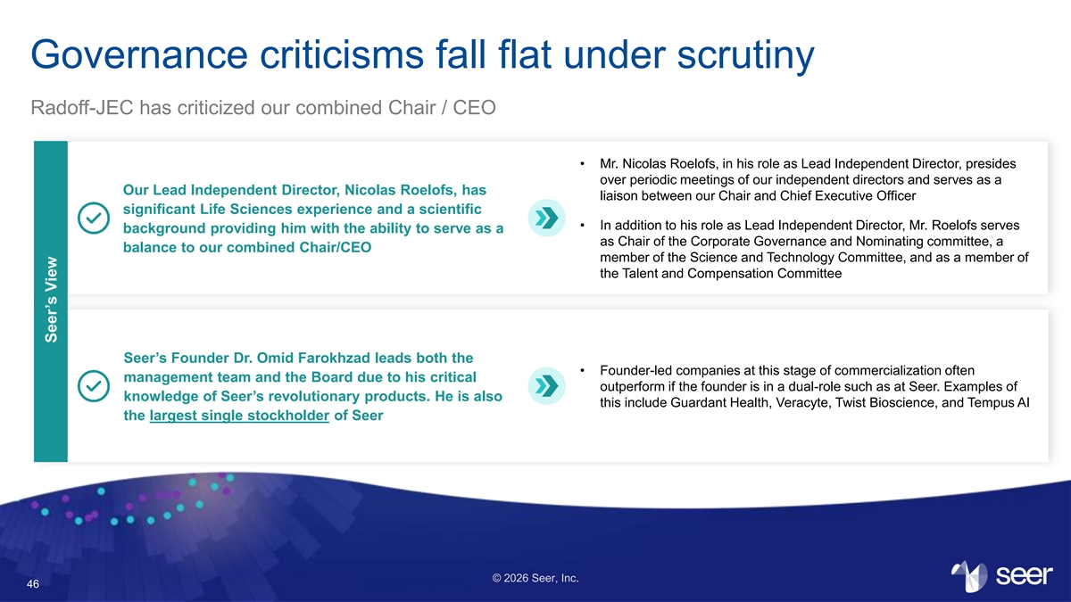
Governance criticisms fall flat under scrutiny Radoff-JEC has criticized our combined Chair / CEO • Mr. Nicolas Roelofs, in his role as Lead Independent Director, presides over periodic meetings of our independent directors and serves as a Our Lead Independent Director, Nicolas Roelofs, has liaison between our Chair and Chief Executive Officer significant Life Sciences experience and a scientific • In addition to his role as Lead Independent Director, Mr. Roelofs serves background providing him with the ability to serve as a as Chair of the Corporate Governance and Nominating committee, a balance to our combined Chair/CEO member of the Science and Technology Committee, and as a member of the Talent and Compensation Committee Seer’s Founder Dr. Omid Farokhzad leads both the • Founder-led companies at this stage of commercialization often management team and the Board due to his critical outperform if the founder is in a dual-role such as at Seer. Examples of knowledge of Seer’s revolutionary products. He is also this include Guardant Health, Veracyte, Twist Bioscience, and Tempus AI the largest single stockholder of Seer © 2026 Seer, Inc. 46 Seer’s View

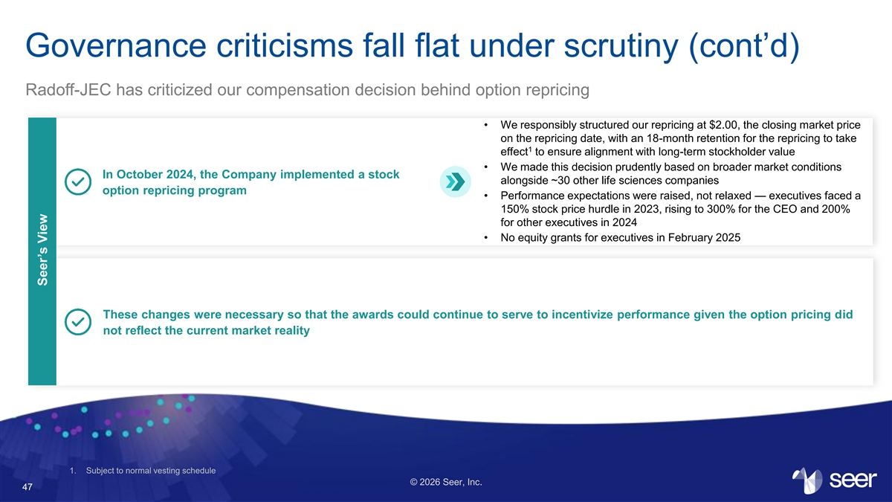
Governance criticisms fall flat under scrutiny (cont’d) Radoff-JEC has criticized our compensation decision behind option repricing • We responsibly structured our repricing at $2.00, the closing market price on the repricing date, with an 18-month retention for the repricing to take 1 effect to ensure alignment with long-term stockholder value • We made this decision prudently based on broader market conditions In October 2024, the Company implemented a stock alongside ~30 other life sciences companies option repricing program • Performance expectations were raised, not relaxed — executives faced a 150% stock price hurdle in 2023, rising to 300% for the CEO and 200% for other executives in 2024 • No equity grants for executives in February 2025 These changes were necessary so that the awards could continue to serve to incentivize performance given the option pricing did not reflect the current market reality 1. Subject to normal vesting schedule © 2026 Seer, Inc. 47 Seer’s View

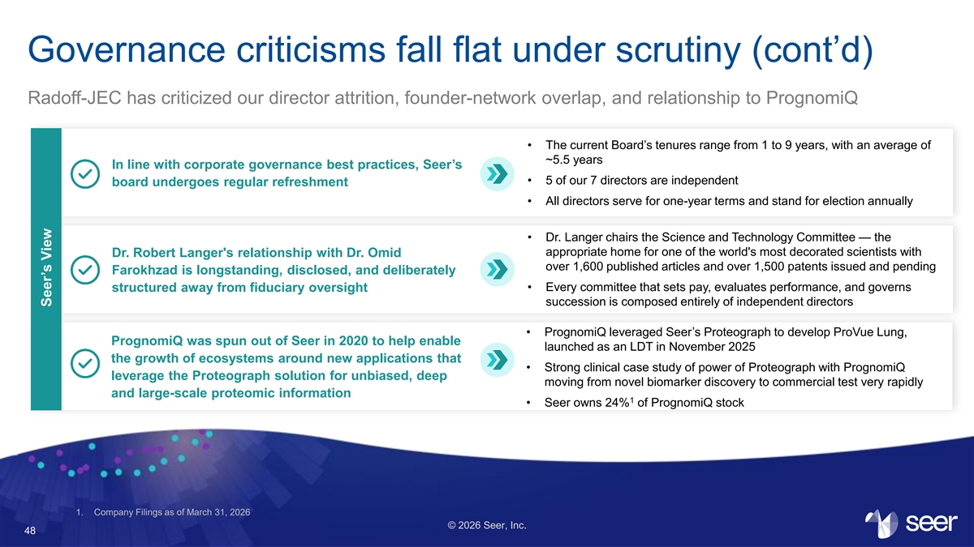
Governance criticisms fall flat under scrutiny (cont’d) Radoff-JEC has criticized our director attrition, founder-network overlap, and relationship to PrognomiQ • The current Board’s tenures range from 1 to 9 years, with an average of ~5.5 years In line with corporate governance best practices, Seer’s • 5 of our 7 directors are independent board undergoes regular refreshment • All directors serve for one-year terms and stand for election annually • Dr. Langer chairs the Science and Technology Committee — the appropriate home for one of the world's most decorated scientists with Dr. Robert Langer's relationship with Dr. Omid over 1,600 published articles and over 1,500 patents issued and pending Farokhzad is longstanding, disclosed, and deliberately structured away from fiduciary oversight • Every committee that sets pay, evaluates performance, and governs succession is composed entirely of independent directors • PrognomiQ leveraged Seer’s Proteograph to develop ProVue Lung, PrognomiQ was spun out of Seer in 2020 to help enable launched as an LDT in November 2025 the growth of ecosystems around new applications that • Strong clinical case study of power of Proteograph with PrognomiQ leverage the Proteograph solution for unbiased, deep moving from novel biomarker discovery to commercial test very rapidly and large-scale proteomic information 1 • Seer owns 24% of PrognomiQ stock 1. Company Filings as of March 31, 2026 © 2026 Seer, Inc. 48 Seer’s View


A Forced Sale Campaign Dressed Up as Governance Reform The Radoff-JEC Campaign © 2026 Seer, Inc. 49

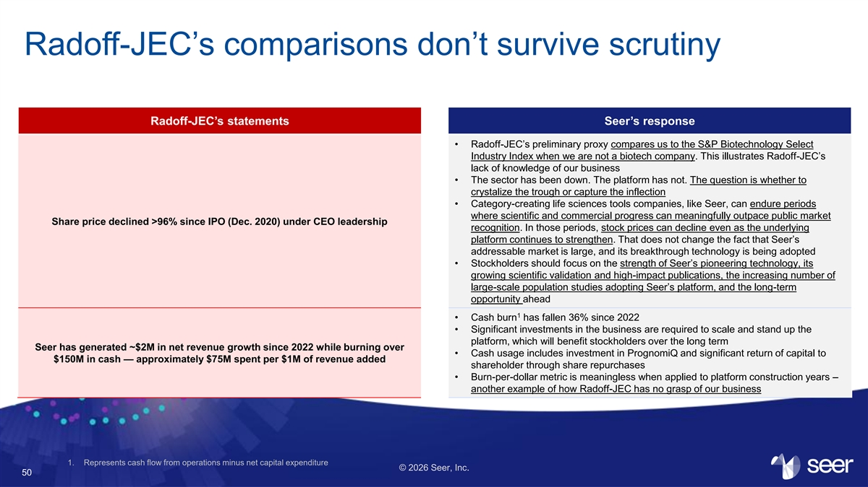
Radoff-JEC’s comparisons don’t survive scrutiny Radoff-JEC’s statements Seer’s response • Radoff-JEC’s preliminary proxy compares us to the S&P Biotechnology Select Industry Index when we are not a biotech company. This illustrates Radoff-JEC’s lack of knowledge of our business • The sector has been down. The platform has not. The question is whether to crystalize the trough or capture the inflection • Category-creating life sciences tools companies, like Seer, can endure periods where scientific and commercial progress can meaningfully outpace public market Share price declined >96% since IPO (Dec. 2020) under CEO leadership recognition. In those periods, stock prices can decline even as the underlying platform continues to strengthen. That does not change the fact that Seer’s addressable market is large, and its breakthrough technology is being adopted • Stockholders should focus on the strength of Seer’s pioneering technology, its growing scientific validation and high-impact publications, the increasing number of large-scale population studies adopting Seer’s platform, and the long-term opportunity ahead 1 • Cash burn has fallen 36% since 2022 • Significant investments in the business are required to scale and stand up the platform, which will benefit stockholders over the long term Seer has generated ~$2M in net revenue growth since 2022 while burning over • Cash usage includes investment in PrognomiQ and significant return of capital to $150M in cash — approximately $75M spent per $1M of revenue added shareholder through share repurchases • Burn-per-dollar metric is meaningless when applied to platform construction years – another example of how Radoff-JEC has no grasp of our business 1. Represents cash flow from operations minus net capital expenditure © 2026 Seer, Inc. 50

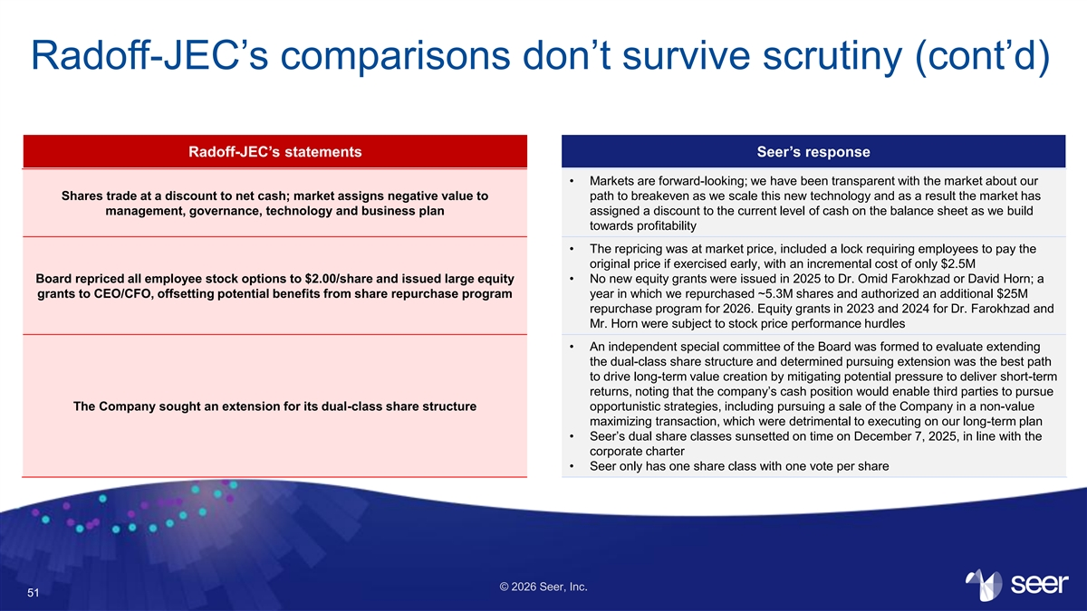
Radoff-JEC’s comparisons don’t survive scrutiny (cont’d) Radoff-JEC’s statements Seer’s response • Markets are forward-looking; we have been transparent with the market about our Shares trade at a discount to net cash; market assigns negative value to path to breakeven as we scale this new technology and as a result the market has management, governance, technology and business plan assigned a discount to the current level of cash on the balance sheet as we build towards profitability • The repricing was at market price, included a lock requiring employees to pay the original price if exercised early, with an incremental cost of only $2.5M Board repriced all employee stock options to $2.00/share and issued large equity • No new equity grants were issued in 2025 to Dr. Omid Farokhzad or David Horn; a grants to CEO/CFO, offsetting potential benefits from share repurchase program year in which we repurchased ~5.3M shares and authorized an additional $25M repurchase program for 2026. Equity grants in 2023 and 2024 for Dr. Farokhzad and Mr. Horn were subject to stock price performance hurdles • An independent special committee of the Board was formed to evaluate extending the dual-class share structure and determined pursuing extension was the best path to drive long-term value creation by mitigating potential pressure to deliver short-term returns, noting that the company’s cash position would enable third parties to pursue The Company sought an extension for its dual-class share structure opportunistic strategies, including pursuing a sale of the Company in a non-value maximizing transaction, which were detrimental to executing on our long-term plan • Seer’s dual share classes sunsetted on time on December 7, 2025, in line with the corporate charter • Seer only has one share class with one vote per share © 2026 Seer, Inc. 51

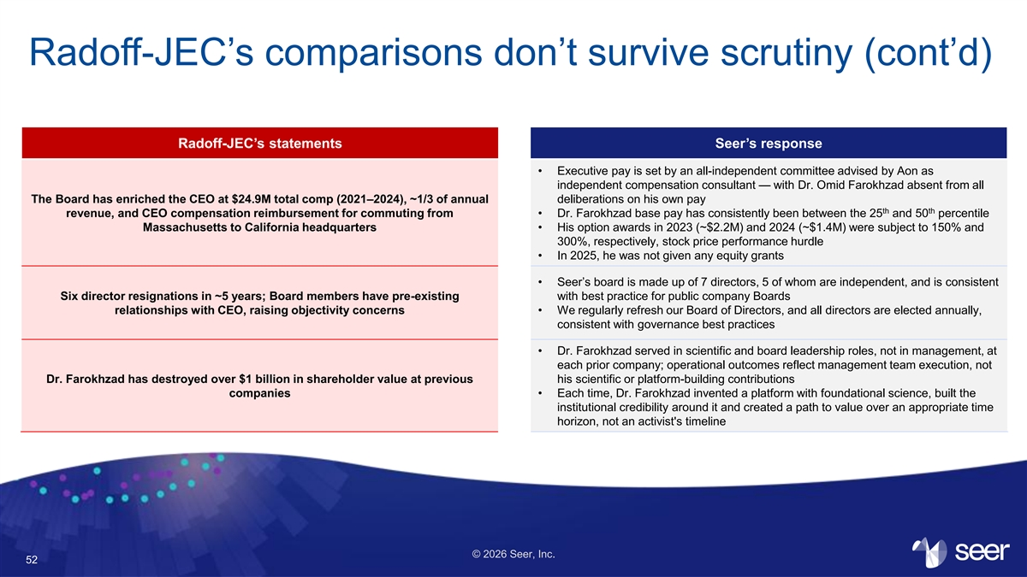
Radoff-JEC’s comparisons don’t survive scrutiny (cont’d) Radoff-JEC’s statements Seer’s response • Executive pay is set by an all-independent committee advised by Aon as independent compensation consultant — with Dr. Omid Farokhzad absent from all The Board has enriched the CEO at $24.9M total comp (2021–2024), ~1/3 of annual deliberations on his own pay th th revenue,​ and CEO compensation reimbursement for commuting from • Dr. Farokhzad base pay has consistently been between the 25 and 50 percentile Massachusetts to California headquarters • His option awards in 2023 (~$2.2M) and 2024 (~$1.4M) were subject to 150% and 300%, respectively, stock price performance hurdle • In 2025, he was not given any equity grants • Seer’s board is made up of 7 directors, 5 of whom are independent, and is consistent Six director resignations in ~5 years; Board members have pre-existing with best practice for public company Boards relationships with CEO, raising objectivity concerns • We regularly refresh our Board of Directors, and all directors are elected annually, consistent with governance best practices • Dr. Farokhzad served in scientific and board leadership roles, not in management, at each prior company; operational outcomes reflect management team execution, not Dr. Farokhzad has destroyed over $1 billion in shareholder value at previous his scientific or platform-building contributions companies • Each time, Dr. Farokhzad invented a platform with foundational science, built the institutional credibility around it and created a path to value over an appropriate time horizon, not an activist's timeline © 2026 Seer, Inc. 52

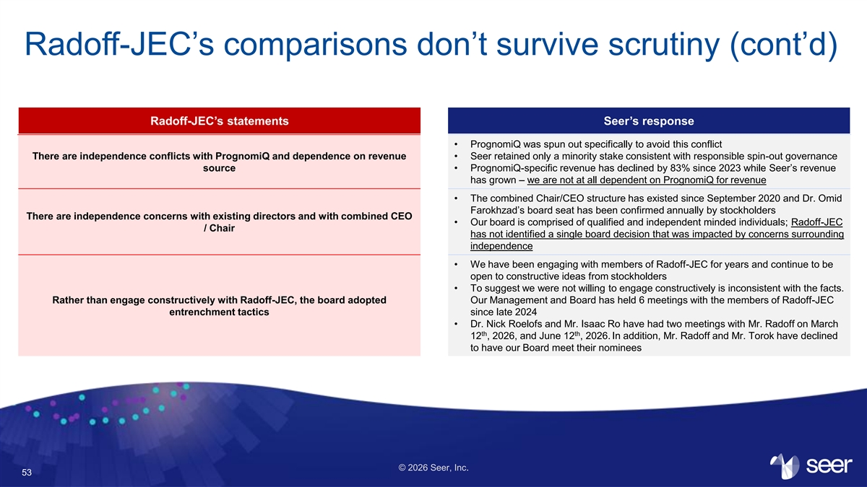
Radoff-JEC’s comparisons don’t survive scrutiny (cont’d) Radoff-JEC’s statements Seer’s response • PrognomiQ was spun out specifically to avoid this conflict There are independence conflicts with PrognomiQ and dependence on revenue • Seer retained only a minority stake consistent with responsible spin-out governance source • PrognomiQ-specific revenue has declined by 83% since 2023 while Seer’s revenue has grown – we are not at all dependent on PrognomiQ for revenue • The combined Chair/CEO structure has existed since September 2020 and Dr. Omid Farokhzad’s board seat has been confirmed annually by stockholders There are independence concerns with existing directors and with combined CEO • Our board is comprised of qualified and independent minded individuals; Radoff-JEC / Chair has not identified a single board decision that was impacted by concerns surrounding independence • We have been engaging with members of Radoff-JEC for years and continue to be open to constructive ideas from stockholders • To suggest we were not willing to engage constructively is inconsistent with the facts. Rather than engage constructively with Radoff-JEC, the board adopted Our Management and Board has held 6 meetings with the members of Radoff-JEC entrenchment tactics since late 2024 • Dr. Nick Roelofs and Mr. Isaac Ro have had two meetings with Mr. Radoff on March th th 12 , 2026, and June 12 , 2026. In addition, Mr. Radoff and Mr. Torok have declined to have our Board meet their nominees © 2026 Seer, Inc. 53


The Wrong People at the Wrong Time for the Wrong Reasons Their Nominees Are the Wrong Answer © 2026 Seer, Inc. 54

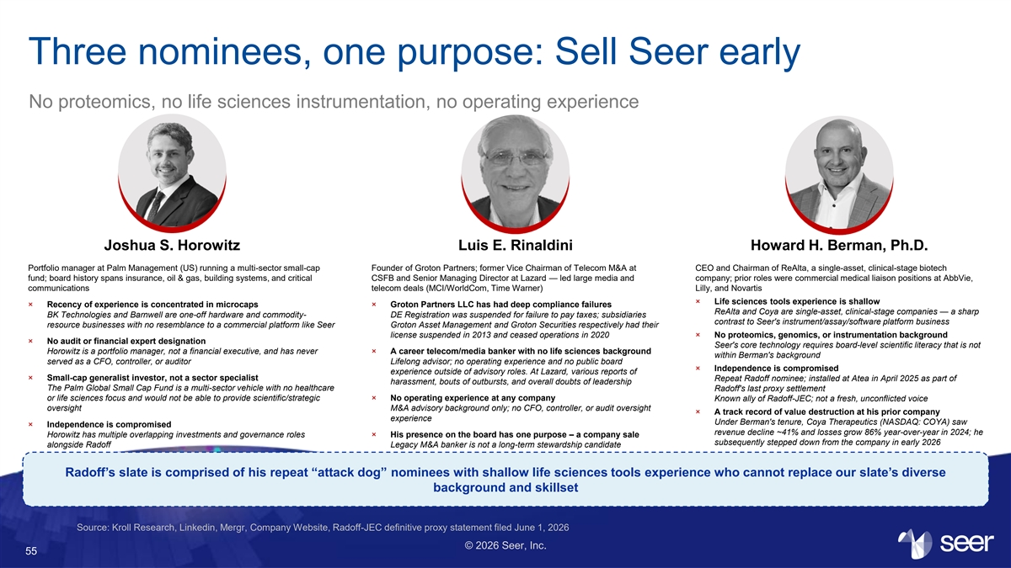
Three nominees, one purpose: Sell Seer early No proteomics, no life sciences instrumentation, no operating experience Joshua S. Horowitz Luis E. Rinaldini Howard H. Berman, Ph.D. Portfolio manager at Palm Management (US) running a multi-sector small-cap Founder of Groton Partners; former Vice Chairman of Telecom M&A at CEO and Chairman of ReAlta, a single-asset, clinical-stage biotech fund; board history spans insurance, oil & gas, building systems, and critical CSFB and Senior Managing Director at Lazard — led large media and company; prior roles were commercial medical liaison positions at AbbVie, communications telecom deals (MCI/WorldCom, Time Warner) Lilly, and Novartis × Life sciences tools experience is shallow × Recency of experience is concentrated in microcaps × Groton Partners LLC has had deep compliance failures ReAlta and Coya are single-asset, clinical-stage companies — a sharp BK Technologies and Barnwell are one-off hardware and commodity- DE Registration was suspended for failure to pay taxes; subsidiaries contrast to Seer's instrument/assay/software platform business resource businesses with no resemblance to a commercial platform like Seer Groton Asset Management and Groton Securities respectively had their license suspended in 2013 and ceased operations in 2020 × No proteomics, genomics, or instrumentation background × No audit or financial expert designation Seer's core technology requires board-level scientific literacy that is not Horowitz is a portfolio manager, not a financial executive, and has never × A career telecom/media banker with no life sciences background within Berman's background served as a CFO, controller, or auditor Lifelong advisor; no operating experience and no public board × Independence is compromised experience outside of advisory roles. At Lazard, various reports of × Small-cap generalist investor, not a sector specialist Repeat Radoff nominee; installed at Atea in April 2025 as part of harassment, bouts of outbursts, and overall doubts of leadership The Palm Global Small Cap Fund is a multi-sector vehicle with no healthcare Radoff's last proxy settlement or life sciences focus and would not be able to provide scientific/strategic × No operating experience at any company Known ally of Radoff-JEC; not a fresh, unconflicted voice oversight M&A advisory background only; no CFO, controller, or audit oversight × A track record of value destruction at his prior company experience Under Berman's tenure, Coya Therapeutics (NASDAQ: COYA) saw × Independence is compromised revenue decline ~41% and losses grow 86% year-over-year in 2024; he Horowitz has multiple overlapping investments and governance roles × His presence on the board has one purpose – a company sale subsequently stepped down from the company in early 2026 alongside Radoff Legacy M&A banker is not a long-term stewardship candidate Radoff’s slate is comprised of his repeat “attack dog” nominees with shallow life sciences tools experience who cannot replace our slate’s diverse background and skillset Source: Kroll Research, Linkedin, Mergr, Company Website, Radoff-JEC definitive proxy statement filed June 1, 2026 © 2026 Seer, Inc. 55

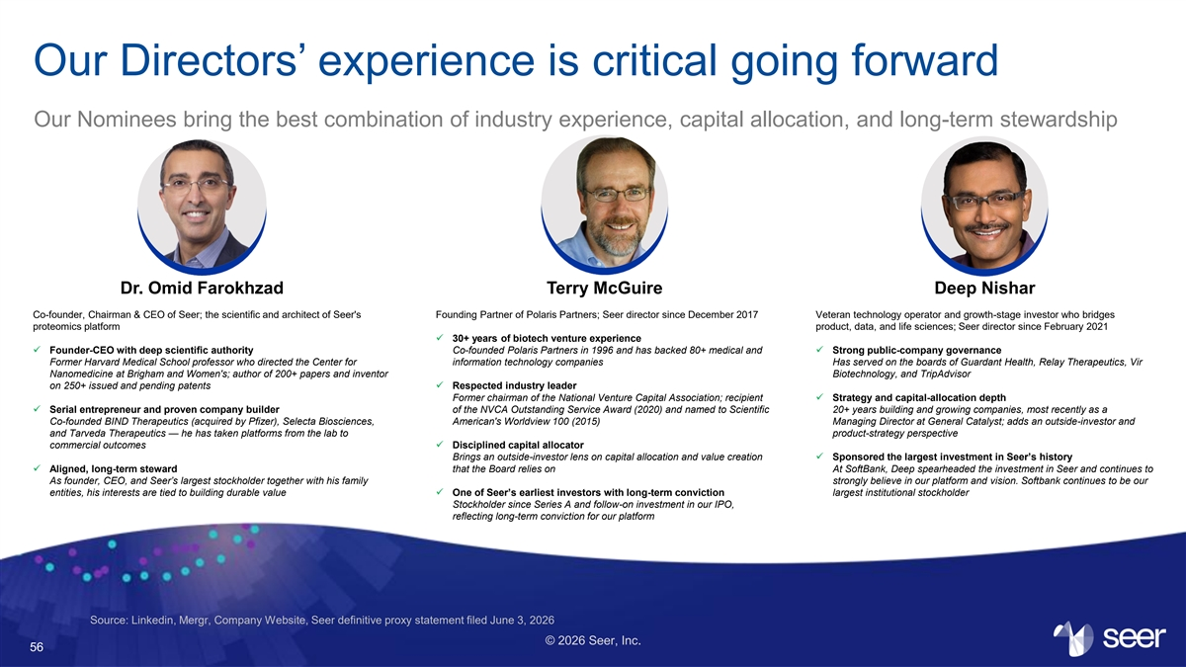
Our Directors’ experience is critical going forward Our Nominees bring the best combination of industry experience, capital allocation, and long-term stewardship Dr. Omid Farokhzad Terry McGuire Deep Nishar Co-founder, Chairman & CEO of Seer; the scientific and architect of Seer's Founding Partner of Polaris Partners; Seer director since December 2017 Veteran technology operator and growth-stage investor who bridges proteomics platform product, data, and life sciences; Seer director since February 2021 ✓ 30+ years of biotech venture experience ✓ Founder-CEO with deep scientific authority Co-founded Polaris Partners in 1996 and has backed 80+ medical and ✓ Strong public-company governance Former Harvard Medical School professor who directed the Center for information technology companies Has served on the boards of Guardant Health, Relay Therapeutics, Vir Nanomedicine at Brigham and Women's; author of 200+ papers and inventor Biotechnology, and TripAdvisor on 250+ issued and pending patents✓ Respected industry leader Former chairman of the National Venture Capital Association; recipient ✓ Strategy and capital-allocation depth ✓ Serial entrepreneur and proven company builder of the NVCA Outstanding Service Award (2020) and named to Scientific 20+ years building and growing companies, most recently as a Co-founded BIND Therapeutics (acquired by Pfizer), Selecta Biosciences, American's Worldview 100 (2015) Managing Director at General Catalyst; adds an outside-investor and and Tarveda Therapeutics — he has taken platforms from the lab to product-strategy perspective commercial outcomes✓ Disciplined capital allocator Brings an outside-investor lens on capital allocation and value creation ✓ Sponsored the largest investment in Seer’s history ✓ Aligned, long-term steward that the Board relies on At SoftBank, Deep spearheaded the investment in Seer and continues to As founder, CEO, and Seer’s largest stockholder together with his family strongly believe in our platform and vision. Softbank continues to be our entities, his interests are tied to building durable value✓ One of Seer’s earliest investors with long-term conviction largest institutional stockholder Stockholder since Series A and follow-on investment in our IPO, reflecting long-term conviction for our platform Source: Linkedin, Mergr, Company Website, Seer definitive proxy statement filed June 3, 2026 © 2026 Seer, Inc. 56

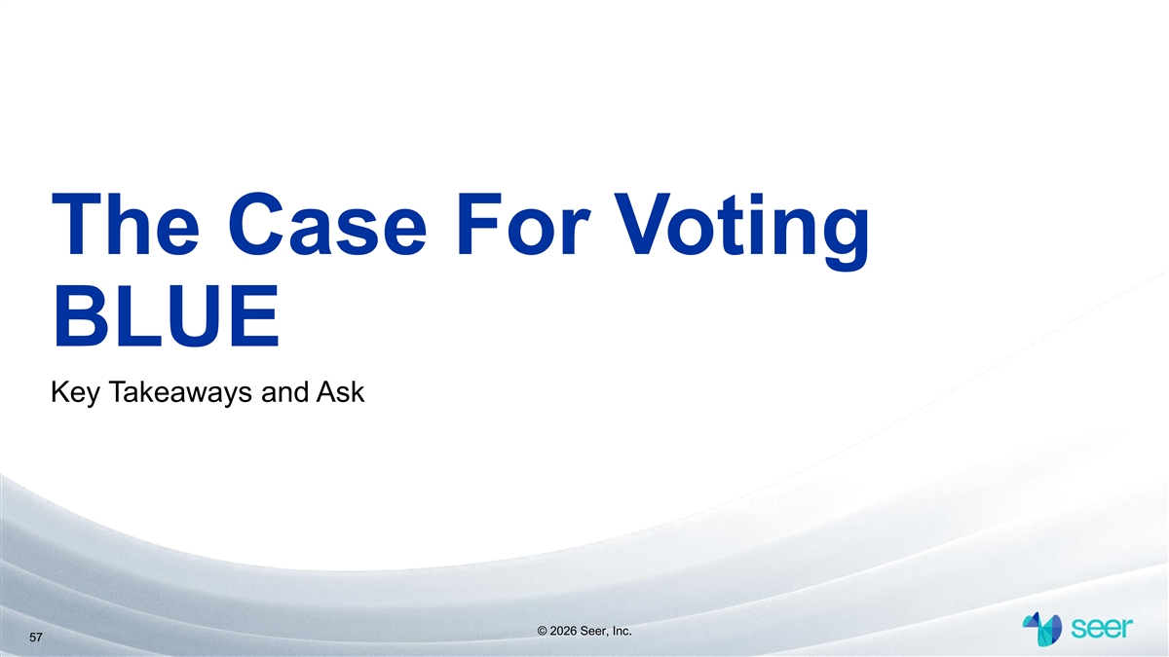
The Case For Voting BLUE Key Takeaways and Ask © 2026 Seer, Inc. 57

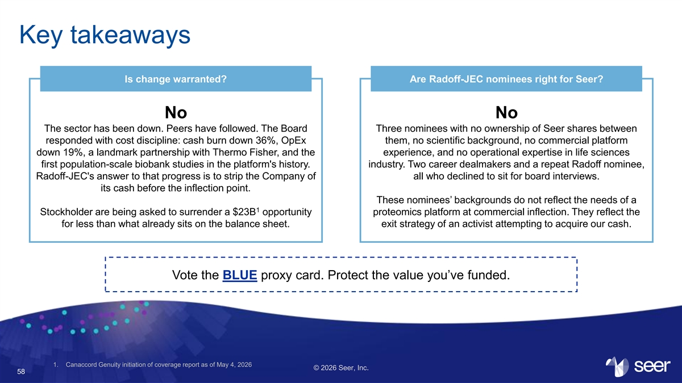
Key takeaways Is change warranted? Are Radoff-JEC nominees right for Seer? No No The sector has been down. Peers have followed. The Board Three nominees with no ownership of Seer shares between responded with cost discipline: cash burn down 36%, OpEx them, no scientific background, no commercial platform down 19%, a landmark partnership with Thermo Fisher, and the experience, and no operational expertise in life sciences first population-scale biobank studies in the platform's history. industry. Two career dealmakers and a repeat Radoff nominee, Radoff-JEC's answer to that progress is to strip the Company of all who declined to sit for board interviews. its cash before the inflection point. These nominees’ backgrounds do not reflect the needs of a 1 Stockholder are being asked to surrender a $23B opportunity proteomics platform at commercial inflection. They reflect the for less than what already sits on the balance sheet. exit strategy of an activist attempting to acquire our cash. Vote the BLUE proxy card. Protect the value you’ve funded. 1. Canaccord Genuity initiation of coverage report as of May 4, 2026 © 2026 Seer, Inc. 58

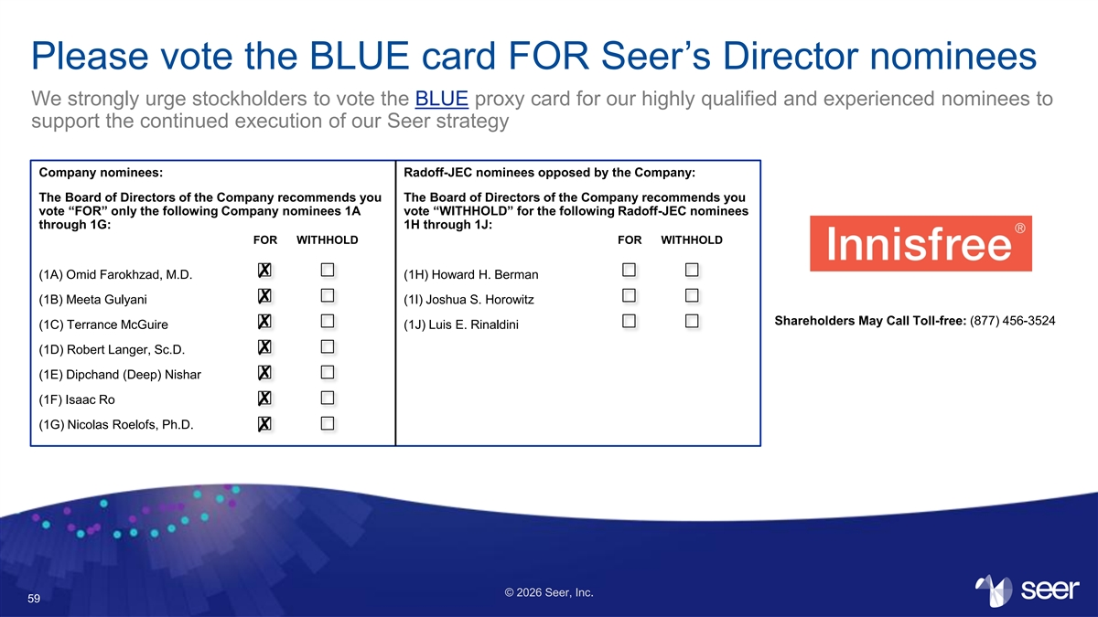
Please vote the BLUE card FOR Seer’s Director nominees We strongly urge stockholders to vote the BLUE proxy card for our highly qualified and experienced nominees to support the continued execution of our Seer strategy Company nominees: Radoff-JEC nominees opposed by the Company: The Board of Directors of the Company recommends you The Board of Directors of the Company recommends you vote “FOR” only the following Company nominees 1A vote “WITHHOLD” for the following Radoff-JEC nominees through 1G: 1H through 1J: FOR WITHHOLD FOR WITHHOLD (1A) Omid Farokhzad, M.D. (1H) Howard H. Berman (1B) Meeta Gulyani (1I) Joshua S. Horowitz Shareholders May Call Toll-free: (877) 456-3524 (1C) Terrance McGuire (1J) Luis E. Rinaldini (1D) Robert Langer, Sc.D. (1E) Dipchand (Deep) Nishar (1F) Isaac Ro (1G) Nicolas Roelofs, Ph.D. © 2026 Seer, Inc. 59


Appendix © 2026 Seer, Inc. 60

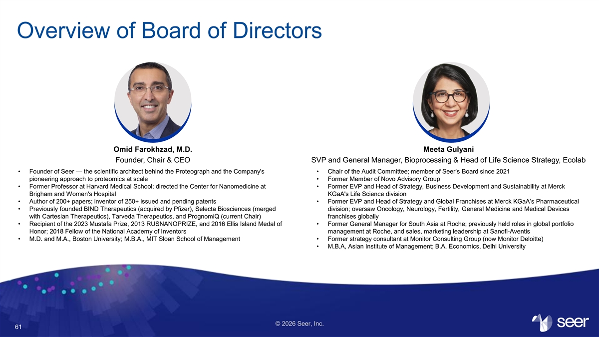
Overview of Board of Directors Omid Farokhzad, M.D. Meeta Gulyani Founder, Chair & CEO SVP and General Manager, Bioprocessing & Head of Life Science Strategy, Ecolab • Founder of Seer — the scientific architect behind the Proteograph and the Company's • Chair of the Audit Committee; member of Seer’s Board since 2021 pioneering approach to proteomics at scale • Former Member of Novo Advisory Group • Former Professor at Harvard Medical School; directed the Center for Nanomedicine at • Former EVP and Head of Strategy, Business Development and Sustainability at Merck Brigham and Women's Hospital KGaA's Life Science division • Author of 200+ papers; inventor of 250+ issued and pending patents • Former EVP and Head of Strategy and Global Franchises at Merck KGaA’s Pharmaceutical • Previously founded BIND Therapeutics (acquired by Pfizer), Selecta Biosciences (merged division; oversaw Oncology, Neurology, Fertility, General Medicine and Medical Devices with Cartesian Therapeutics), Tarveda Therapeutics, and PrognomiQ (current Chair) franchises globally • Recipient of the 2023 Mustafa Prize, 2013 RUSNANOPRIZE, and 2016 Ellis Island Medal of • Former General Manager for South Asia at Roche; previously held roles in global portfolio Honor; 2018 Fellow of the National Academy of Inventors management at Roche, and sales, marketing leadership at Sanofi-Aventis • M.D. and M.A., Boston University; M.B.A., MIT Sloan School of Management • Former strategy consultant at Monitor Consulting Group (now Monitor Deloitte) • M.B.A, Asian Institute of Management; B.A. Economics, Delhi University © 2026 Seer, Inc. 61

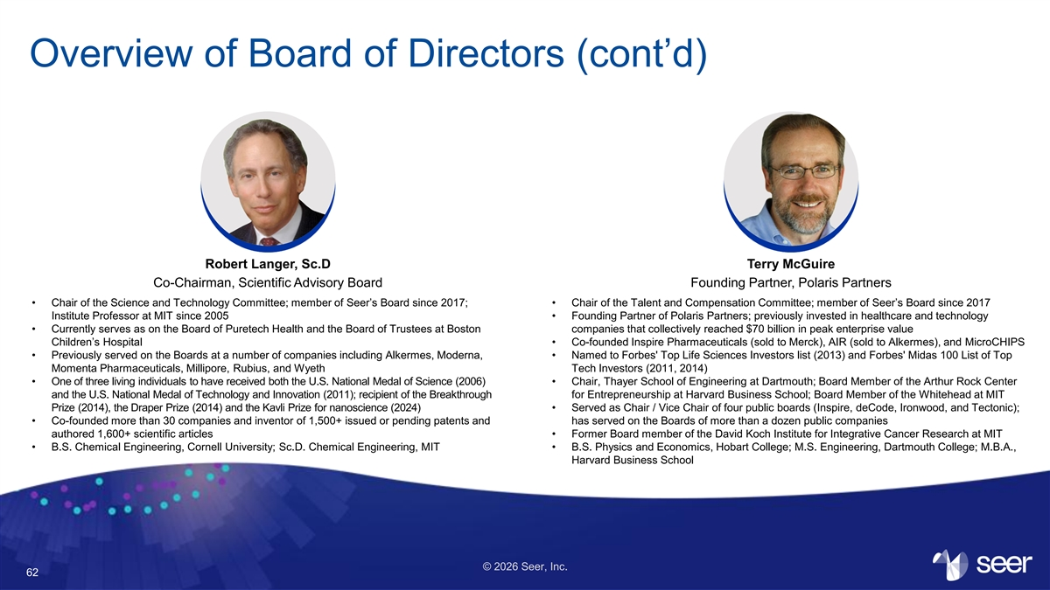
Overview of Board of Directors (cont’d) Robert Langer, Sc.D Terry McGuire Co-Chairman, Scientific Advisory Board Founding Partner, Polaris Partners • Chair of the Science and Technology Committee; member of Seer’s Board since 2017; • Chair of the Talent and Compensation Committee; member of Seer’s Board since 2017 Institute Professor at MIT since 2005 • Founding Partner of Polaris Partners; previously invested in healthcare and technology • Currently serves as on the Board of Puretech Health and the Board of Trustees at Boston companies that collectively reached $70 billion in peak enterprise value Children’s Hospital • Co-founded Inspire Pharmaceuticals (sold to Merck), AIR (sold to Alkermes), and MicroCHIPS • Previously served on the Boards at a number of companies including Alkermes, Moderna, • Named to Forbes' Top Life Sciences Investors list (2013) and Forbes' Midas 100 List of Top Momenta Pharmaceuticals, Millipore, Rubius, and Wyeth Tech Investors (2011, 2014) • One of three living individuals to have received both the U.S. National Medal of Science (2006) • Chair, Thayer School of Engineering at Dartmouth; Board Member of the Arthur Rock Center and the U.S. National Medal of Technology and Innovation (2011); recipient of the Breakthrough for Entrepreneurship at Harvard Business School; Board Member of the Whitehead at MIT Prize (2014), the Draper Prize (2014) and the Kavli Prize for nanoscience (2024) • Served as Chair / Vice Chair of four public boards (Inspire, deCode, Ironwood, and Tectonic); • Co-founded more than 30 companies and inventor of 1,500+ issued or pending patents and has served on the Boards of more than a dozen public companies authored 1,600+ scientific articles • Former Board member of the David Koch Institute for Integrative Cancer Research at MIT • B.S. Chemical Engineering, Cornell University; Sc.D. Chemical Engineering, MIT • B.S. Physics and Economics, Hobart College; M.S. Engineering, Dartmouth College; M.B.A., Harvard Business School © 2026 Seer, Inc. 62

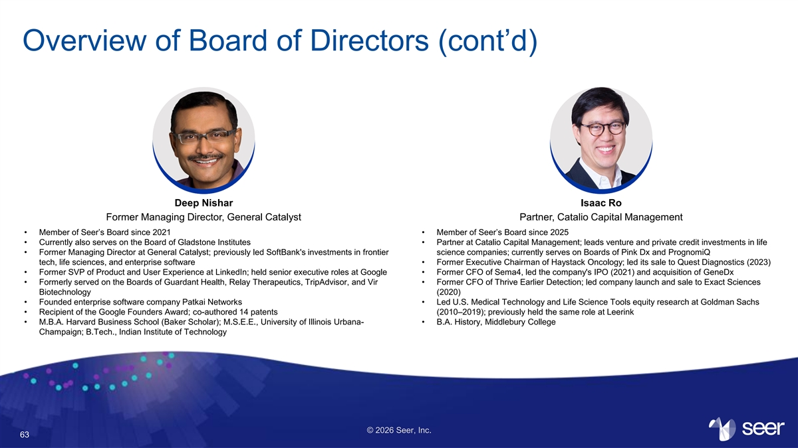
Overview of Board of Directors (cont’d) Deep Nishar Isaac Ro Former Managing Director, General Catalyst Partner, Catalio Capital Management • Member of Seer’s Board since 2021 • Member of Seer’s Board since 2025 • Currently also serves on the Board of Gladstone Institutes • Partner at Catalio Capital Management; leads venture and private credit investments in life • Former Managing Director at General Catalyst; previously led SoftBank's investments in frontier science companies; currently serves on Boards of Pink Dx and PrognomiQ tech, life sciences, and enterprise software • Former Executive Chairman of Haystack Oncology; led its sale to Quest Diagnostics (2023) • Former SVP of Product and User Experience at LinkedIn; held senior executive roles at Google • Former CFO of Sema4, led the company's IPO (2021) and acquisition of GeneDx • Formerly served on the Boards of Guardant Health, Relay Therapeutics, TripAdvisor, and Vir • Former CFO of Thrive Earlier Detection; led company launch and sale to Exact Sciences Biotechnology (2020) • Founded enterprise software company Patkai Networks • Led U.S. Medical Technology and Life Science Tools equity research at Goldman Sachs • Recipient of the Google Founders Award; co-authored 14 patents (2010–2019); previously held the same role at Leerink • M.B.A. Harvard Business School (Baker Scholar); M.S.E.E., University of Illinois Urbana- • B.A. History, Middlebury College Champaign; B.Tech., Indian Institute of Technology © 2026 Seer, Inc. 63

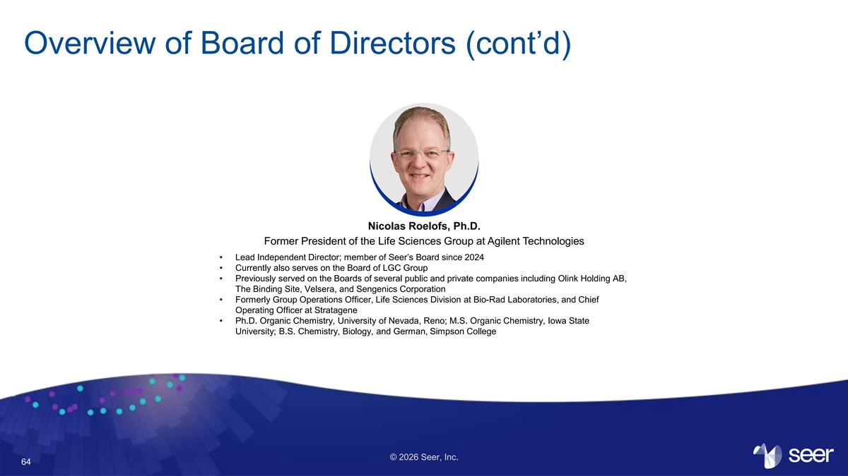
Overview of Board of Directors (cont’d) Nicolas Roelofs, Ph.D. Former President of the Life Sciences Group at Agilent Technologies • Lead Independent Director; member of Seer’s Board since 2024 • Currently also serves on the Board of LGC Group • Previously served on the Boards of several public and private companies including Olink Holding AB, The Binding Site, Velsera, and Sengenics Corporation • Formerly Group Operations Officer, Life Sciences Division at Bio-Rad Laboratories, and Chief Operating Officer at Stratagene • Ph.D. Organic Chemistry, University of Nevada, Reno; M.S. Organic Chemistry, Iowa State University; B.S. Chemistry, Biology, and German, Simpson College © 2026 Seer, Inc. 64



